

CSIT 321 - Project

Final Report

Project Topic: CSIT-24-S3-08

(Multi-factor transaction authorisation based on QR code)

Group Number: FYP-24-S3-11

Member’s Name | UOWID | Email
Matthew Chin Yu Kang | 7768990 | mykchin001@mymail.sim.edu.sg
Randall Lim Shi Hao | 8107002 | rshlim001@mymail.sim.edu.sg
Teo Wei Zhi Zakary | 7769258 | wzzteo001@mymail.sim.edu.sg
Mahina Lim Fong Jia | 8378885 | mfjlim002@mymail.sim.edu.sg
Ryzlan Afiq Bin Roslan | 7895124 | ryzlanab001@mymail.sim.edu.sg

Supervisor
Mr Chua Zong Fu

Assessor
Mr Japit Sionggo

1. Introduction 4
2. Software used (tech stack) 4
Continuous Deployment 4
NextJs 5
Java 5
MySQL 5
Conclusion 6
3. Requirement Specification 6
Functional Requirements 6
Non-Functional Requirements 8
Other Requirements 9
Business model 9
Value Propositions 9
Customer Segments 9
Channels 9
Customer Relationships 10
Future Plan 11
4. WBS 11
5. Design spec 13
6. Related diagram 13
Use Case Diagram 14
Use case Description 18
Webpage 18
User 18
Admin 29
Director 37
Mobile 50
User 50
Director 55
Sequence Diagram 60
Webpage 60
Admin 68
Director 72
Mobile 78
Function Hierarchy Diagram 84
7. WireFrame 86
Webpage 86
Login page for user and director 86
Viewing of rooms for User and Director 87
Confirmation of booking 87
Feedback form for room 87
List of current bookings 89
Login page for Admin 89
Homepage for Admin 90
Page to manage rooms 90
Page to manage users 91
Page to view feedback on particular room 91
Account details page 92
Mobile 92
User and Director login page 92
User and Director View Booking 93
User and Director scan QR code 93
User and Director Biometric scan 94
Successful Biometric and receive PIN 94
8. Prototype 95
9. Database Design 95

1. Introduction
A transaction is a fundamental interaction or exchange between parties where something of value, such as goods, services, money, or information, changes hands based on mutual agreement regarding the terms and conditions. Transactions are integral to various contexts, including financial markets, business operations, and everyday interactions, providing the basis for economic activity and organisational efficiency.
In our project, transactions play a crucial role in the booking system for meeting rooms. When a user selects a date and time to reserve a room, a transaction is initiated to exchange information and verify availability. This involves a seamless process where the application checks the room's availability, generates a QR code for the confirmed booking, and triggers multi-factor authentication (MFA) to ensure secure user confirmation. This series of interactions ensures that the booking is accurately recorded and that only authorised users can access the reserved meeting room.
This project aims to create a secure and efficient room booking system that leverages modern technologies to facilitate transactions. By integrating real-time availability checks, QR code generation, and MFA, the system ensures that the booking process is user-friendly and secure. This approach not only enhances user experience but also improves the overall management of meeting room reservations, contributing to better organisational efficiency and resource utilisation.

2. Software used (tech stack)
For our application, we are using MySQL as the shared database to ensure data consistency and reliability across both the web and mobile platforms. For the web application, we have chosen Next.js for both the frontend and backend due to its powerful server-side rendering capabilities and built-in API routes, which enable seamless integration with the MySQL database and provide a fast, consistent user experience. On the mobile side, we are using Java for the frontend, taking advantage of its performance and compatibility with Android devices. This architecture allows both platforms to interface directly with MySQL, creating a unified data layer that ensures consistent user experiences across the board.

CI/CD Pipeline for Deployment
For our website's development, we will create a dedicated GitHub repository where the team will collaborate using the Next.js framework. To streamline deployment, we have chosen Vercel as our hosting platform.
Key Benefits of Vercel Integration:
- Continuous Deployment: Vercel automatically sets up a continuous deployment pipeline. Any code pushed to the main branch of our GitHub repository will immediately trigger a new deployment, ensuring fast and consistent updates.
- Optimised Builds: With Vercel, we benefit from optimised builds and fast performance tailored specifically for Next.js projects.
- Automatic Scaling: Vercel handles traffic spikes effortlessly with its built-in automatic scaling capabilities.
- Developer-Centric Features: The user-friendly interface, reliability, and developer-oriented features of Vercel make it an ideal choice for efficient application deployment.
Include screenshots here illustrating:
- GitHub to Vercel Integration Overview
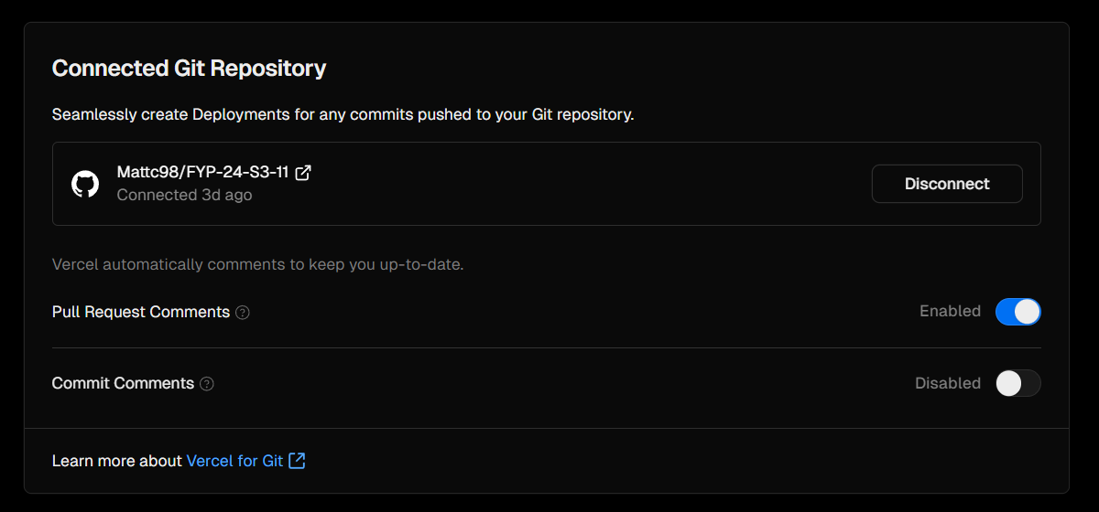
- Example Deployment Logs on Vercel's Dashboard
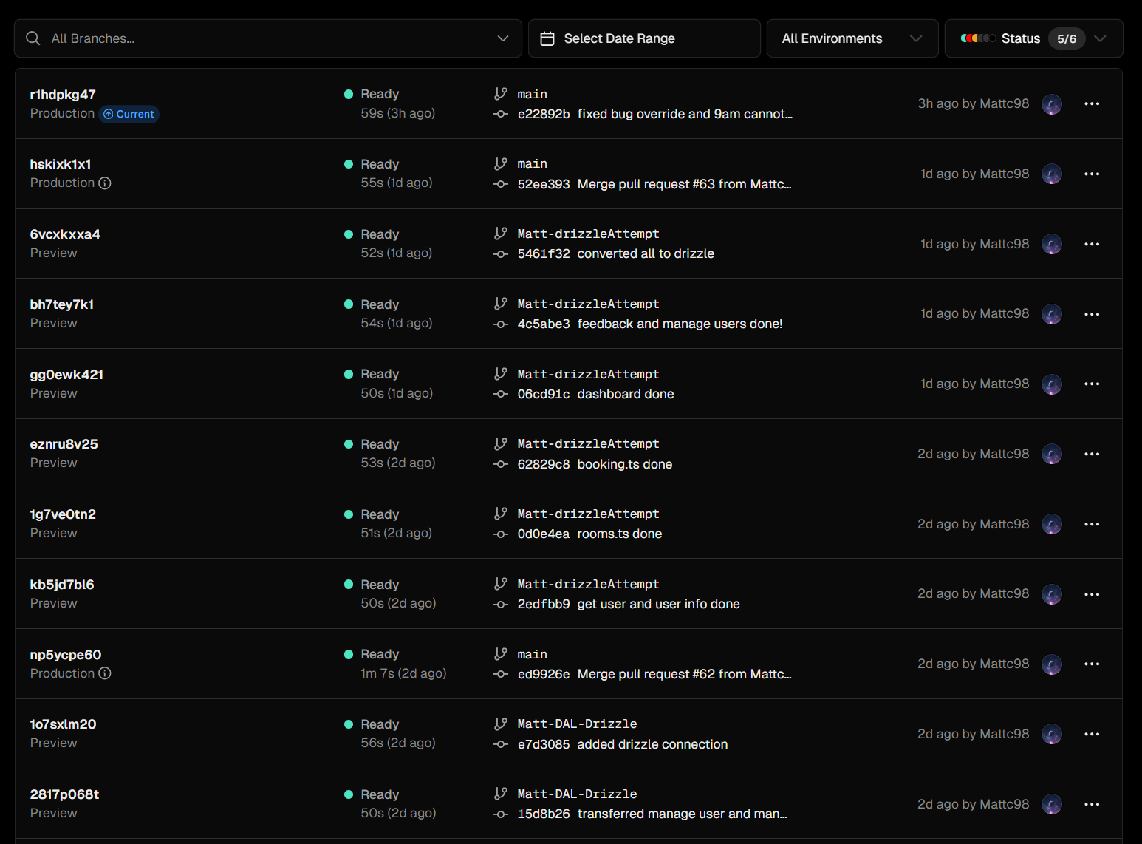
- Github Pull requests
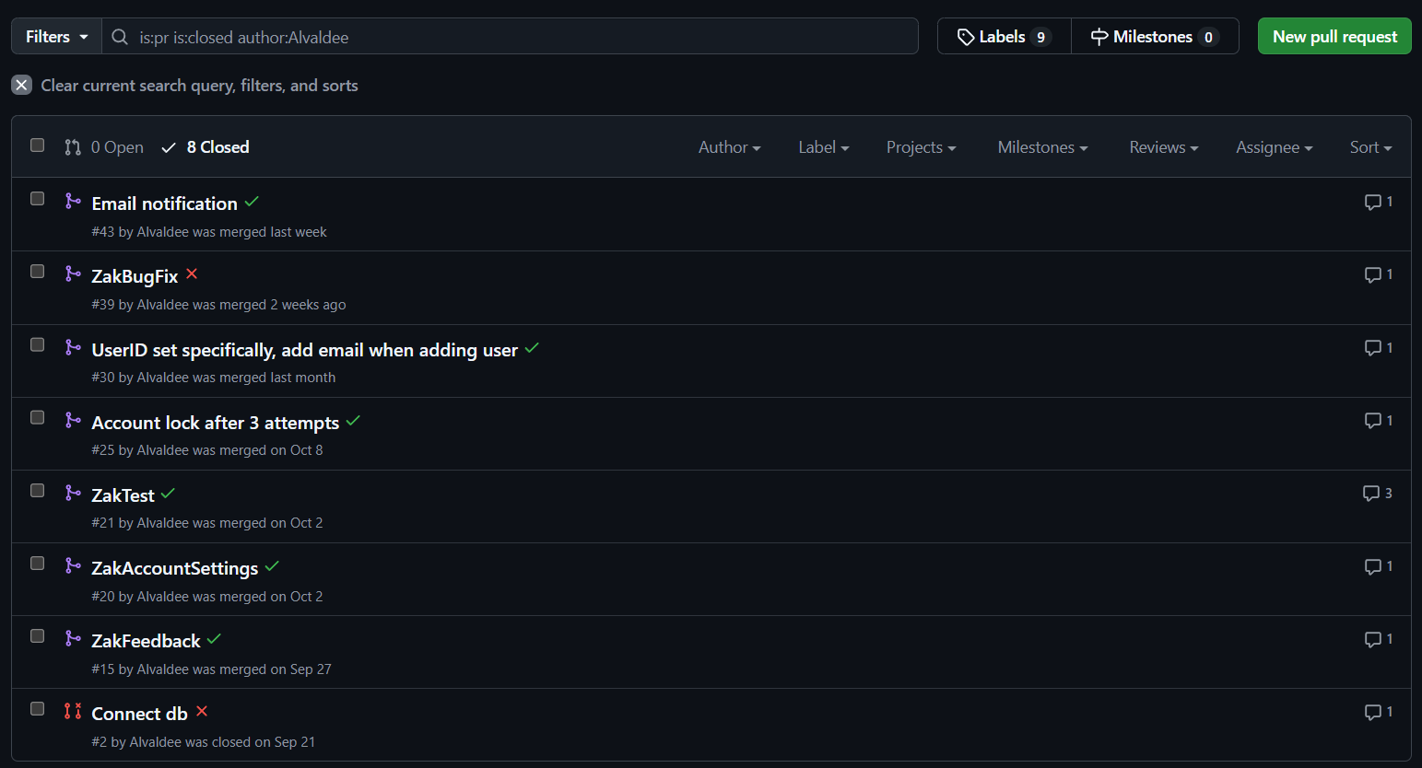
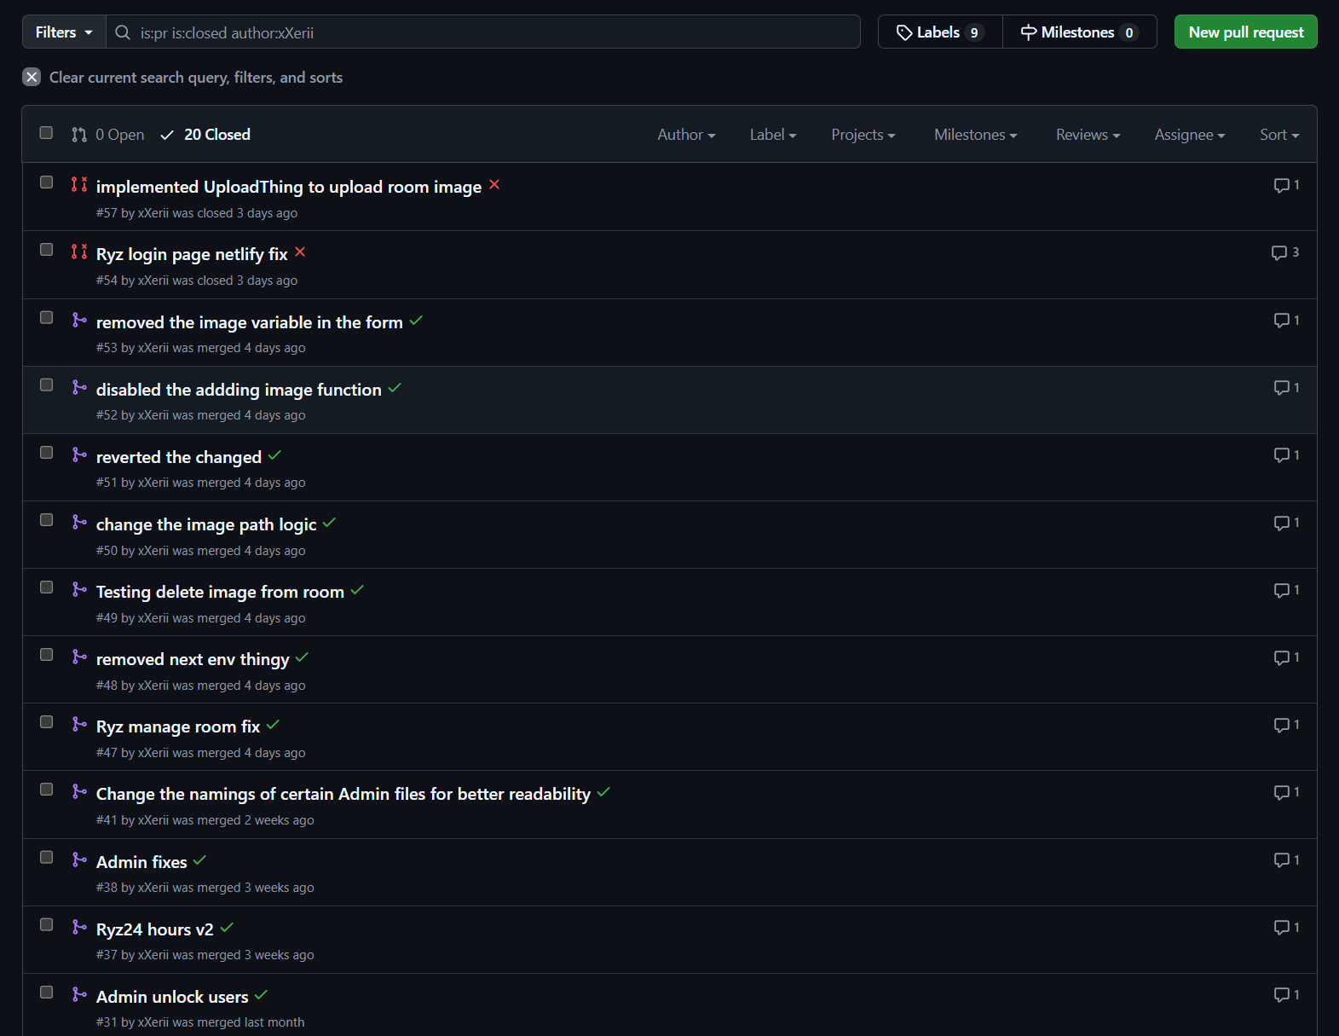
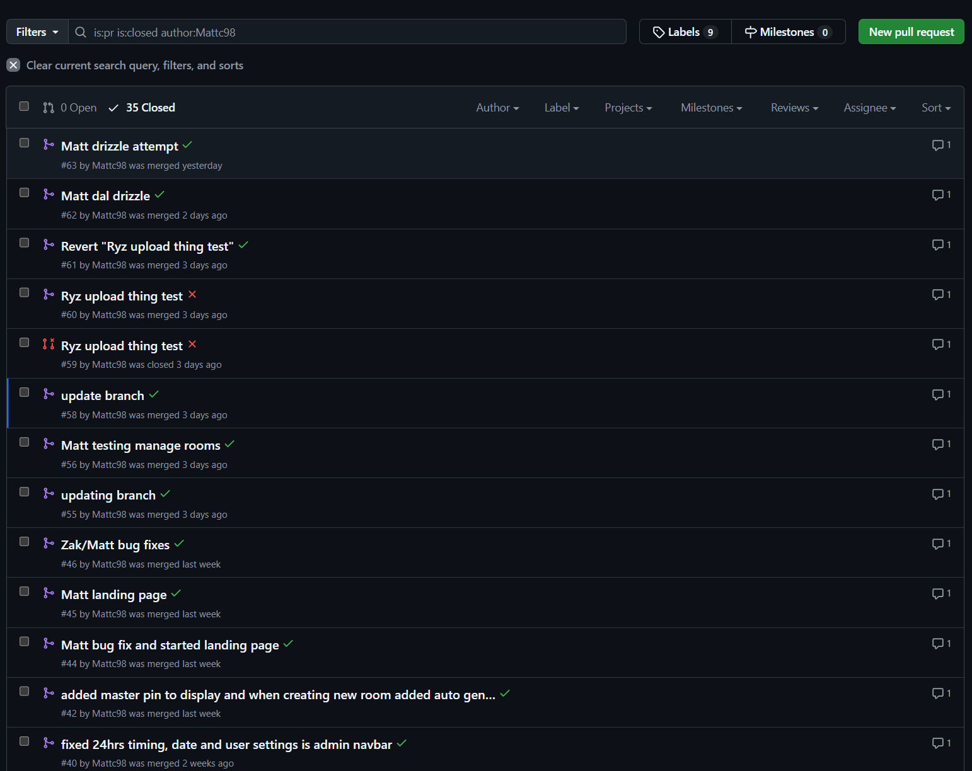
- User Interface for Managing Deployments in Vercel
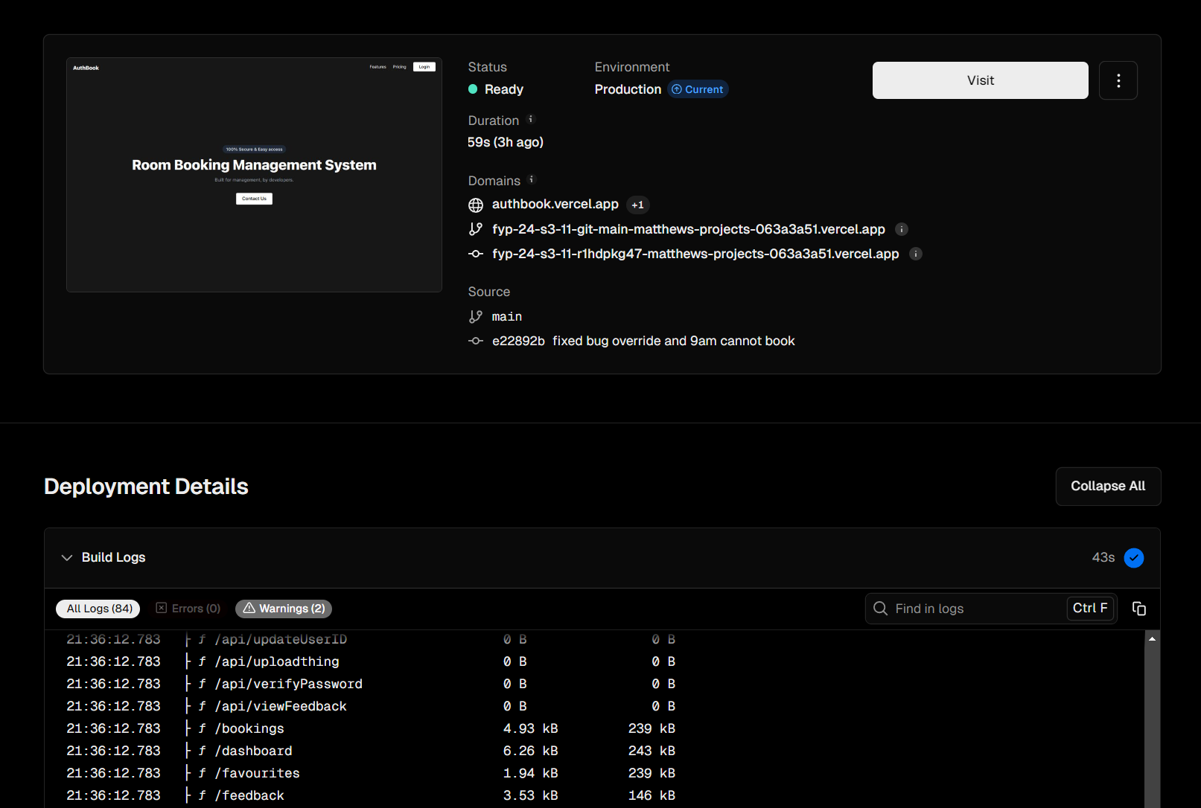

NextJs
Why NextJs? Mainly because it's a framework that’s built upon React. It’s SEO (Search Engine Optimisation) friendly, so the chances of our site being ranked higher when using a search engine is higher. Next.js makes use of server-side rendering, which improves online application speed by reducing first-page load time, increasing content access, engagement, and satisfaction, particularly on mobile devices, consequently improving user experience.

There were other frontend framework choices, such as Angular, Vue.js, Qwik, and many others. However, Angular, while powerful and feature-rich, can be complex and have a steeper learning curve, which might slow down our development process. Vue.js, although easier to learn and flexible, may not offer the same level of ecosystem maturity and server-side rendering capabilities as Next.js. Qwik, being relatively new, lacks the extensive community and resources available with more established frameworks. Ultimately, we chose Next.js for its built-in components, libraries, and compatibility with modern web standards, allowing us to quickly develop an MVP. This decision enables us to gather user feedback and make necessary adjustments efficiently, without wasting time on setup and configuration.

Java
Java is our choice for mobile app development because it is a well-established and widely used programming language for building Android applications. Its object-oriented nature and robust libraries make it ideal for creating stable and high-performance mobile applications. Java offers excellent support for multithreading and seamless integration with the Android SDK, which is crucial for developing responsive and interactive user interfaces.
While Kotlin is another popular choice for Android development and offers modern language features, its relative newness means that Java still holds a broader base of existing code, documentation, and community support. Swift is excellent for iOS development, but since our focus is on Android, it doesn't meet our platform requirements. React Native provides cross-platform capabilities but may require compromises in performance and access to native features, which can be critical for complex apps.
Additionally, we have prior experience with Java, making us more familiar and comfortable with its development environment, which helps streamline our workflow and reduce potential learning curves. Overall, we chose Java for its proven track record and reliability in building complex Android applications, leveraging existing expertise to deliver a high-quality mobile experience efficiently.

MySQL
We selected MySQL as our database solution due to its reliability, performance, and scalability, which are critical for supporting both our web and mobile platforms. MySQL is a powerful relational database management system that provides robust transaction support and ACID compliance, ensuring data integrity and consistency across our application. Its efficient query processing and indexing capabilities help optimise performance for read-heavy workloads, which is essential for delivering fast response times to our users.
While considering other options, we found that PostgreSQL, though highly versatile and with advanced features, can be more complex to set up and manage for simpler applications. MongoDB, being a NoSQL database, excels in handling unstructured data but might not be the best fit for our application’s relational data model. Oracle offers robust enterprise solutions but comes with higher costs and complexity, which may not be necessary for our needs.
Moreover, our familiarity with MySQL from previous projects allows us to leverage our existing knowledge and skills, enhancing our ability to set up, manage, and optimise the database efficiently. MySQL is open-source, widely used, and offers a large community, extensive documentation, and a variety of tools for database management and administration. This makes it cost-effective and easier to integrate into our existing technology stack. Its flexibility allows us to scale our database infrastructure as our user base grows, supporting both vertical and horizontal scaling. This choice allows us to focus on developing our application without being hindered by database management complexities.

Cloud Server
We chose AWS as our cloud provider to take advantage of its robust infrastructure and scalability for hosting both our application and database. Specifically, AWS EC2 (Elastic Compute Cloud) will host our Spring Boot application, transforming it into a REST API server that allows seamless communication with our mobile app. By deploying the Spring Boot REST API on EC2, we ensure that the application can scale up or down as needed, accommodating varying levels of user demand without compromising performance.

Additionally, AWS RDS (Relational Database Service) with MySQL provides a fully managed database solution, making it ideal for our requirements. By hosting our MySQL database on RDS, we benefit from automated backups, maintenance, and patching, which frees up time for development and reduces the risk of data loss. RDS also integrates smoothly with EC2, allowing our REST API to interact with the database securely and efficiently. AWS's combination of EC2 for application hosting and RDS for database management offers a cost-effective, scalable, and reliable solution, making it an excellent choice for powering the backend infrastructure and supporting seamless data retrieval for our mobile app.

Drizzle ORM
To bridge the gap between our Next.js backend and MySQL, we are leveraging Drizzle ORM. Drizzle offers a modern, type-safe approach to database interaction in JavaScript and TypeScript, making it a powerful tool for managing our data models and queries. Unlike traditional ORMs that may be cumbersome and slow, Drizzle focuses on lightweight, composable query building, which allows for precise and efficient database operations. This makes our codebase more maintainable and improves productivity by reducing boilerplate code while enhancing type safety and error checking.
Drizzle’s flexible architecture integrates seamlessly with Next.js, enabling rapid iteration during development while maintaining strong adherence to data validation and integrity rules. This integration, combined with its compatibility with MySQL, makes Drizzle an excellent choice to meet our project requirements without compromising on performance or scalability. Its focus on modern development practices, such as immutability and composability, aligns well with our agile approach, ensuring that our database interactions are predictable, robust, and easy to debug.
Additionally, Drizzle ORM offers built-in protection against SQL injection attacks. By using parameterized queries and automatically escaping user inputs, Drizzle minimizes the risk of injection vulnerabilities that can compromise application security. This security feature ensures that any data provided by the user is treated safely and processed correctly, adding another layer of defense to our application’s backend and reinforcing trust and safety for our

Uploadthing
Uploadthing is a modern file handling and uploading solution designed to streamline the process of uploading, managing, and serving files in web applications. It offers a robust, developer-friendly API that simplifies the implementation of secure and scalable file uploads. With built-in support for features like file transformations, access controls, and seamless integration with modern frameworks, Uploadthing is an essential tool for managing user-generated content efficiently in any web-based project.

Conclusion
To strategically select our tech stack, we devised a comprehensive comparison table that evaluated our team's proficiency across various technologies. This table was instrumental in determining our strengths, guiding us to choose Next.js for both front and back-end development and Java for mobile development, based on high competence scores. This methodical approach ensured that our technology choices not only aligned with our project requirements but also leveraged our team's existing skills, maximising our efficiency and effectiveness in the development process.
The decision table link: “https://docs.google.com/spreadsheets/d/19mW6q1wEsh0nYeJOReeHb31Op8zgL_N1/edit?gid=1911573079#gid=1911573079”

3. Network Diagram
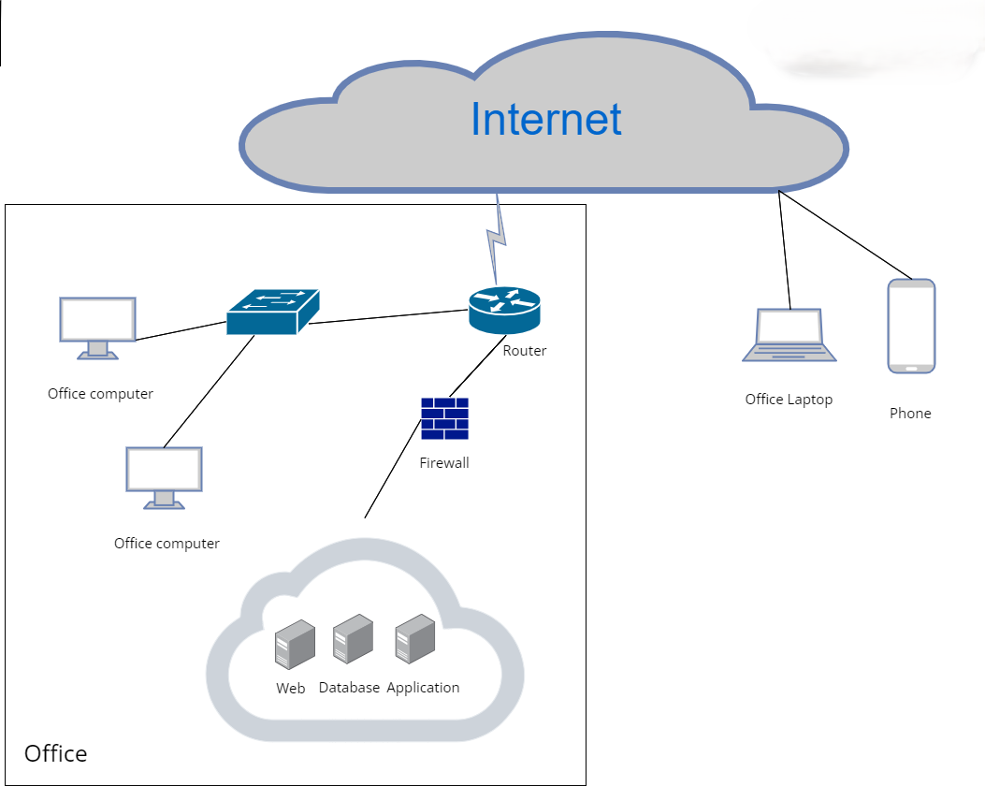

For our server architecture, we have opted to utilise cloud-based solutions extensively. Specifically, our web server will be hosted on GitHub, providing a robust platform for code management and deployment. Meanwhile, our database will be hosted on AWS, leveraging its scalable infrastructure to handle our data needs efficiently.

Using a Cloud Server: Benefits
- Space Efficiency: By using cloud servers, we significantly reduce the physical space required for server hardware within our office environment.
- Cost Savings: Cloud solutions are often more cost-effective, reducing the need for upfront capital expenditure on hardware and ongoing maintenance costs.
Cons of Cloud Servers:
- Recovery Time and Availability: One potential drawback is the slower recovery time compared to setups with built-in redundancy. This not only delays the resumption of normal operations but also affects the availability of services to users if there is an issue with the cloud services. Redundancy allows for quick failover, merely switching to a backup server if the primary server fails.
Firewall Configuration:
- Our network diagram highlights the strategic placement of a firewall between the router and the server. This setup is crucial for protecting our most sensitive data assets (often referred to as the "crown jewels"). The firewall scrutinizes both internal and external packets attempting to access the server. It ensures that only whitelisted packets are allowed through, while others are dropped, bolstering our security measures.
Backup and Recovery Strategy:
- We recommend backing up the server through periodic snapshots, taken every six months. This approach is cost-effective and helps in maintaining a recent backup of our system state.
- However, a downside to this strategy is the potential impact on recovery times during server downtimes. While redundancy would allow for immediate failover to an alternate server, the costs are considerably higher. Additionally, the reliance on periodic snapshots every six months could result in data loss if a failure occurs before the next snapshot is taken. This gap between snapshots means that any data generated after the last snapshot and before the failure will not be recoverable, potentially impacting business operations and data integrity.

4. Requirement Specification

Functional Requirements
- User Authentication
- The system shall allow users to create accounts with a username, password.
- The system must validate the format of the username and password (e.g., minimum password length, allowable characters.)
- The system must validate the username and password.
- Room Booking
- Users shall be able to search for available rooms based on date and time.
- Users shall be able to book a room and receive confirmation.
- Users shall be able to view, modify, and cancel their bookings.
- User feedback
- Users shall be able to provide feedback about the room after their booking ends.

- User Account Management
- The system shall allow users to edit their own account information, specifically enabling password changes.

- Admin Management
- Admins shall be able to add, update, or remove rooms.
- Admins shall be able to manage user accounts, including adding, updating, or deleting accounts.
- Admins shall be able to review all room bookings and receive notifications about changes.
- Admin shall be able to review all the feedback.
- Admin can change the break glass password
- Director features
- Director shall have the ability to override existing bookings.
- Director shall be able to book exclusive rooms that are not available to regular users.

- Session Security
- The system must automatically log out users after a period of inactivity to ensure account security.

- Mobile
- Mobile users/directors shall be able to login and log out to secure their accounts.
- Mobile users/directors shall use (MFA) biometric data combined with a QR code scan to authenticate and receive PIN for the room.
- Mobile users/directos can view their upcoming booking
- Mobile admin can enter the break glass password to access the room

- Notification
- The system should automatically send an email notification to the user with the pin details.
- The system should automatically send an email notification when director override the user booking

Non-Functional Requirements
- Performance
- The system should handle up to 100 concurrent users without performance degradation.
- Response time for booking search queries should be less than 2 seconds.
- Reliability
- The system should have an uptime of 99.9%.
- Backup procedures should ensure data recovery within 4 hours in case of a failure.
- Implement automatic failover mechanisms to minimise downtime during server failures.

- Security
- All data transmission should use HTTPS to ensure data encryption.
- All passwords must be a minimum of 8 characters and consist of 1 uppercase, lowercase, number and symbols.
- The system should comply with data protection regulations such as PDPR.
- Scalability
- The system should be able to scale to accommodate an increasing number of users and bookings.
- Maintainability
- The system should be modular to allow for easy updates and maintenance.
- Comprehensive documentation should be provided for future developers.
- User Feedback Mechanisms
- Incorporate easy-to-use feedback forms within the mobile app, allowing users to report issues or suggest improvements directly from their devices.
- Compatibility
- The system must be compatible across multiple browsers (e.g., Chrome, Firefox, Safari, Edge)
- The system must be compatible across all android phone

Other Requirements

Business model

Value Propositions
The mission of this project is to develop and deploy an application that makes use of a web interface, a QR code, and the user’s biometric information within the application. This will be used to book certain rooms for use.

The application and website will require an account to log in. The web interface will generate the QR code which will be scanned using the mobile application. Once a transaction has been made between the system and the user, the system will provide a pin which will be the password for the room and will become accessible to them.

Customer Segments
The main users of this product are companies whose members need to hold meetings in certain rooms, as such they will make use of the webpage to book the meeting room and they use the QR code to access the room.
The targeted audience segment for this application consists primarily of medium to large enterprises, establishing it firmly within a business-to-business (B2B) model. These businesses, particularly in sectors such as technology, finance, and consulting, require sophisticated space management solutions to handle their meeting room efficiencies effectively. By adopting this application, companies can enhance resource allocation, streamline administrative processes, and improve the overall workplace environment, thereby boosting productivity and collaboration among teams.

Channels
Our product can be promoted via channels such as social media advertising. It is a good way to reach our target customers who make use of such platforms. Additionally, our marketing strategy includes:
- Content Marketing: Utilising blogs, articles, and informative videos that highlight the unique features and benefits of our application. This content can be shared across our website and social media channels to drive organic traffic and educate potential users.
- Influencer Partnerships: Collaborating with influencers and thought leaders in the tech and business community to promote our application, thereby leveraging their follower base and credibility.
- Email Marketing: Sending targeted email campaigns to potential customers, including businesses and individuals who may benefit from our room booking solution. This can include newsletters, product updates, and exclusive offers.
- Search Engine Optimization (SEO): Optimising our web content to appear higher in search engine results, making it easier for users to find our application when searching for room booking solutions online.
- Paid Search Advertising (PPC): Using platforms like Google Ads to run pay-per-click campaigns that target specific keywords related to our service, driving traffic to our website and app store pages.
- Public Relations (PR): Issuing press releases and seeking coverage in industry publications and news outlets to increase awareness and credibility.
For the distribution of our product, the following channels will be used:
- App Stores: The mobile application will be available on major app stores such as the Apple App Store and Google Play Store, ensuring easy access for iOS and Android users.
- Web Interface Deployment: The web interface will be hosted on a secure, scalable cloud platform, accessible via any web browser. This ensures that users can book rooms using the application.
By leveraging these promotional and distribution channels, we aim to maximise our reach and ensure that our application is accessible to all potential users.

Customer Relationships
Since the product is planned to start out in the niche market, it is all right to communicate with our customers as best as we can.

Support provided can come in the form of personal assistance between the user and us developers, which can be carried out during or after deployment of the product.
We will focus on the following strategies to build and maintain strong customer relationships:
- Dedicated Customer Support:
  - Personal Assistance: Offering personalised support through direct communication channels such as email, chat, and phone. This will be available during business hours and extended to after-hours support as needed.
  - Onboarding Assistance: Providing guided onboarding sessions to help new users set up and familiarise themselves with the application, ensuring a smooth start.
- User Community:
  - Online Forums: Establishing online forums or community groups where users can ask questions, share experiences, and provide feedback. This will also serve as a platform for peer-to-peer support.
  - Social Media Engagement: Actively engaging with users on social media platforms, responding to queries, and participating in conversations to build a sense of community and trust.
- Self-Service Resources:
  - Comprehensive Knowledge Base: Creating a detailed knowledge base with articles, tutorials, FAQs, and troubleshooting guides to help users find answers to common questions independently.
  - Video Tutorials: Producing video tutorials and webinars that demonstrate how to use various features of the application, catering to different learning styles.
- Proactive Customer Engagement:
  - Regular Updates: Keeping users informed about new features, updates, and improvements through newsletters, in-app notifications, and blog posts.
  - Feedback Loops: Actively seeking feedback through surveys, user interviews, and feedback forms to understand user needs and improve the product continuously.
- Loyalty Programs:
  - Referral Programs: Implementing referral programs to incentivize existing users to refer new users, rewarding them with discounts or premium features.
  - Loyalty Rewards: Offering loyalty rewards or discounts to long-term users as a token of appreciation for their continued support.
- Customer Success Initiatives:
  - Customer Success Managers: Assigning customer success managers to key accounts to ensure they derive maximum value from the application and address any issues promptly.
  - Periodic Check-ins: Conducting regular check-ins with users to understand their experience, offer assistance, and gather insights for further development.
- Events and Webinars:
  - User Meetups: Organising virtual and in-person meetups or user conferences to build stronger relationships, share knowledge, and gather community feedback.
  - Educational Webinars: Hosting webinars to educate users on best practices, new features, and industry trends relevant to room booking and management.
By implementing these strategies, we aim to cultivate strong, lasting relationships with our customers, ensuring their satisfaction and fostering loyalty to our application.

5. Deployment Diagram
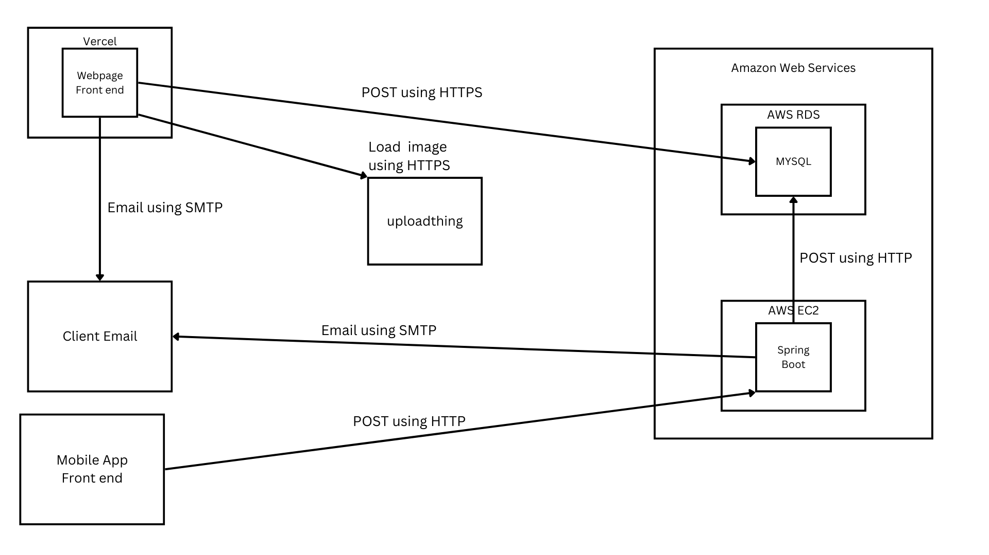
- Vercel: Acts as the host for the webpage frontend. It communicates with other services to post data using HTTPS, load images, and send emails through SMTP.
- Mobile App Frontend: Interacts directly with AWS services by posting data via HTTP.
- Amazon Web Services (AWS):
  - AWS RDS (MySQL): Serves as the database for the system, storing data that is accessed.
  - AWS EC2 (Spring Boot): Hosts the backend application which interacts with both the database on AWS RDS and the frontends, receiving and sending data over HTTP.
- Email Communication:
  - Both the webpage hosted on Vercel and the backend on AWS EC2 can send emails using SMTP. These emails are directed to client email addresses, for notifications.
- Image Storage with UploadThing:
  - Instead of local storage, images are managed through the uploadthing service, which allows the application to load images via HTTPS.

6. WBS

Item | Task | Start Date | End Date | Completion days | User
1 | Learning Stack | 08/07/2024 | 19/07/2024 | 12 | All
2 | Introduction | 20/07/2024 | 27/07/2024 | 7 | Matthew, Mahina
3 | Project Scope | 20/07/2024 | 27/07/2024 | 7 | Matthew
4 | Deliverables | 20/07/2024 | 27/07/2024 | 7 | Mahina, Randall
5 | Research | 20/07/2024 | 02/08/2024 | 14 | Zakary, Ryzlan
6 | Stretch Goal | 20/07/2024 | 27/07/2024 | 7 | Matthew
7 | User Stories | 27/07/2024 | 30/07/2024 | 4 | All
7.1 | User Stories (Mobile) | 27/07/2024 | 30/07/2024 | 4 | Mahina
7.2 | User Stories (Webpage) | 27/07/2024 | 30/07/2024 | 4 | Zakary, Ryzlan, Randall, Matthew
8 | Business model | 03/08/2024 | 07/08/2024 | 5 | Randall
9 | Non functional Requirement | 03/08/2024 | 07/08/2024 | 5 | Mahina, Matthew
10 | Functional Requirement | 03/08/2024 | 07/08/2024 | 5 | Mahina, Matthew
11 | Project Purpose | 03/08/2024 | 07/08/2024 | 5 | Zakary
12 | Prototyping Web | 03/08/2024 | 25/08/2024 | 23 | Ryzlan
13 | Use case description | 10/08/204 | 16/08/2024 | 7 | All
13.1 | Use case description (Mobile) | 10/08/204 | 16/08/2024 | 7 | Mahina
13.2 | Use case description (Webpage) | 10/08/204 | 16/08/2024 | 7 | Matthew , Randall, Zakary
14 | Use case diagram | 10/08/204 | 16/08/2024 | 7 | Mahina
15 | WireFrame | 17/08/2024 | 30/08/2024 | 14 | Mahina, Zakary
16 | Sequence Diagram | 17/08/2024 | 13/09/2024 | 28 | All
17 | Database Design | 17/08/2024 | 5/09/2024 | 20 | Matthew, Randall, Mahina
18 | Prototyping Mobile | 31/08/2024 | 13/09/2024 | 14 | Ryzlan
19 | Presentation slide | 08/09/2024 | 18/09/2024 | 11 | All
20 | Functional Hierarchy | 14/09/2024 | 18/09/2024 | 5 | Ryzlan
21 | Hosting Database | 19/09/2024 | 22/09/2024 | 4 | Ryzlan, Zakary
22 | Hosting webpage | 19/09/2024 | 22/09/2024 | 4 | Matthew, Mahina
23 | Web Page for login and logout | 19/09/2024 | 27/09/2024 | 9 | Ryzlan, Matthew
24 | Mobile for login and logout | 19/09/2024 | 11/10/2024 | 23 | Randall, Mahina, Zakary
25 | CRUD for User and Director Room booking  User stories (User 2,3,4,5,11 Director 2,4,5,6,8,11) | 28/09/2024 | 11/10/2024 | 14 | Matthew
26 | Create spring boot and host it on AWS (EC2) | 28/09/2024 | 11/10/2024 | 14 | Mahina, Zakary
27 | Mobile view booking | 28/09/2024 | 11/10/2024 | 14 | Mahina, Zakary, Randall
28 | User and director view/update account  User stories (User 6,7  Director 12,13) | 28/09/2024 | 04/10/2024 | 7 | Matthew
29 | User and Director give feedback  User stories (User 8  Director 9) | 05/10/2024 | 11/10/2024 | 7 | Zakary
30 | Director override a booking  User Stories(Director 3) | 05/10/2024 | 11/10/2024 | 7 | Matthew
31 | User and Director save favourites room  User stories (User 10 Director 10) | 05/10/2024 | 11/10/2024 | 7 | Matthew, Ryzlan
32 | Admin edit room  User stories (Admin 1) | 12/10/2024 | 18/10/2024 | 7 | Ryzlan
33 | Admin review all room  User stories (Admin 2) | 12/10/2024 | 18/10/2024 | 7 | Ryzlan
34 | Admin CRUD user account  User stories (Admin 3, 4, 5, 8) | 19/10/2024 | 25/10/2024 | 7 | Ryzlan, Zakary
35 | Admin Unlock lock account User stories (admin 9) | 19/10/2024 | 25/10/2024 | 7 | Ryzlan
36 | Mobile scan QR code  User Stories (User 4, Director 4) | 12/10/2024 | 18/10/2024 | 7 | Mahina, Ryzlan
37 | Mobile Biometric | 12/10/2024 | 18/10/2024 | 7 | Ryzlan, Zakary
38 | Mobile Email PIN | 19/10/2024 | 25/10/2024 | 7 | Mahina
39 | Email notification for override. (Webpage) | 26/10/2024 | 01/11/2024 | 7 | Zakary, Matthew
40 | Break glass password (webpage) | 26/10/2024 | 01/11/2024 | 7 | Matthew
41 | Break glass password (Mobile) | 26/10/2024 | 01/11/2024 | 7 | Mahina
42 | Mobile Testcase | 26/10/2024 | 01/11/2024 | 7 | Mahina
43 | WebpageTestcase | 26/10/2024 | 01/11/2024 | 7 | Matthew
44 | User Manual | 26/10/2024 | 08/11/2024 | 14 | Randall, Matthew
45 | Record Video | 01/11/2024 | 08/11/2024 | 7 | All
46 | Landing page | 01/11/2024 | 08/11/2024 | 7 | Matthew
47 | Deployment Diagram | 01/11/2024 | 08/11/2024 | 7 | Mahina, Zakary
48 | Bug Fixes (Mobile) | 26/10/2024 | 08/11/2024 | 14 | Mahina, Ryzlan
49 | Bug Fixes (Webpage) | 26/10/2024 | 08/11/2024 | 14 | Matthew, Ryzlan, Zakary
50 | Edit ERD and populate database | 01/11/2024 | 08/11/2024 | 7 | Zaraky
51 | Webpage hardening (Drizzle ORM) | 09/11/2024 | 13/11/2024 | 5 | Matthew
52 | Overall Design and CSS of the website | 09/11/2024 | 13/11/2024 | 5 | Matthew
54 | Edit Sequence Diagram | 09/11/2024 | 13/11/2024 | 5 | Ryzlan, Randall, Mahina
55 | Edit Use case Description | 09/11/2024 | 13/11/2024 | 5 | Mahina, Matthew, Ryzlan, Randall
56 | Video editing | 09/11/2024 | 15/11/2024 | 5 | Ryzlan
57 | Final presentation slide | 09/11/2024 | 13/11/2024 | 5 | all
58 | Final check document | 26/10/2024 | 08/11/2024 | 5 | All

7. Related diagram

Use Case Diagram
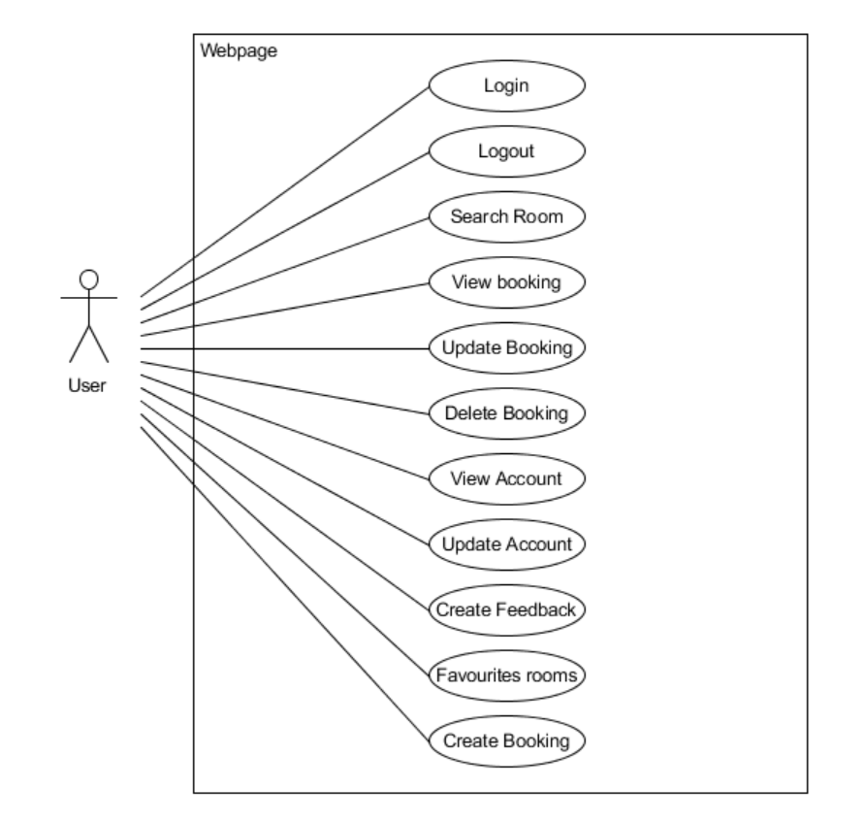
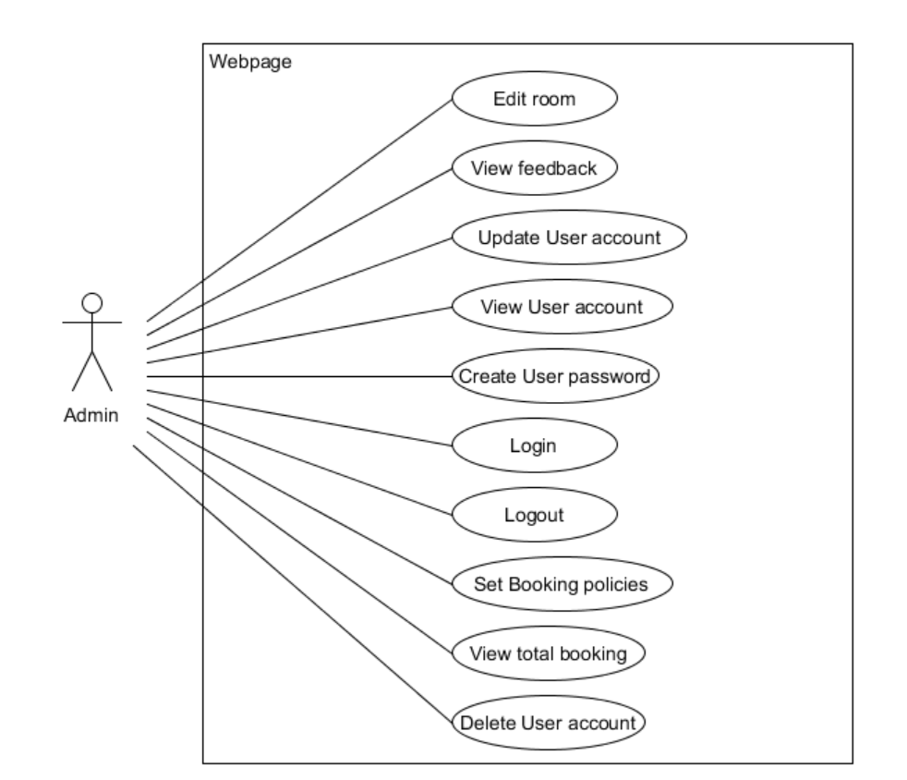
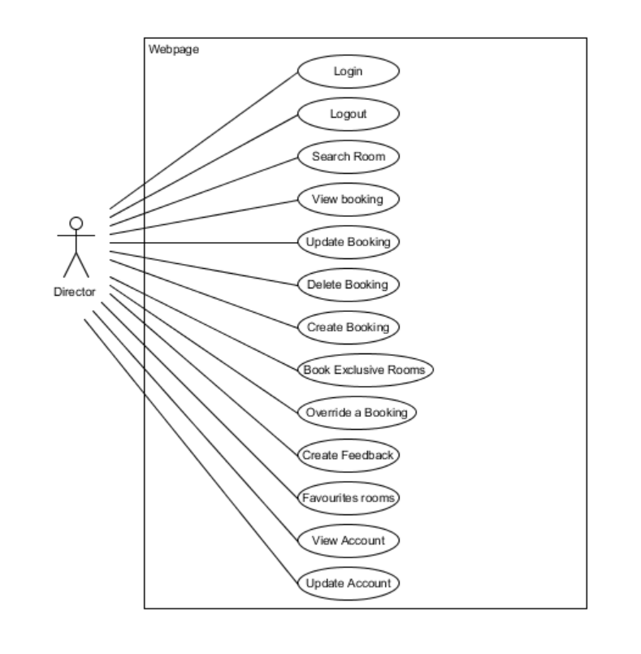

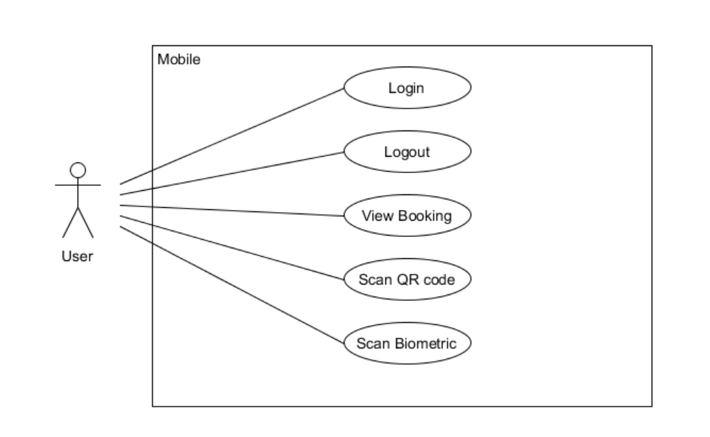
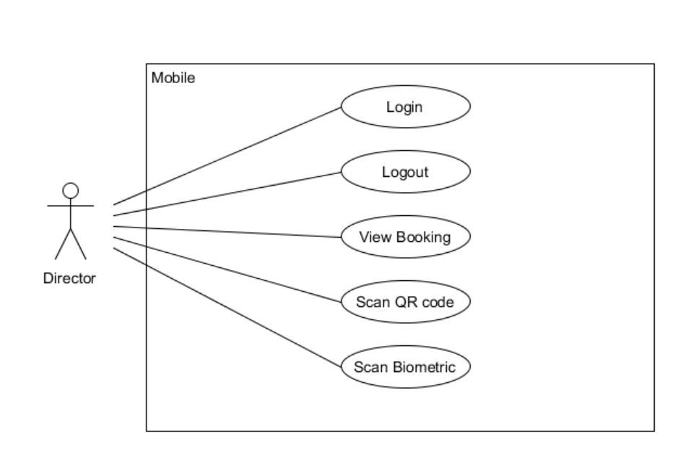

Use case Description

Webpage

User

User Stories: As a user, I want to login,So that my account remains secure from unauthorised access.
Name: WebPage User login | Use Case ID: #1
Stakeholder and goals: User - Aims to securely access the system by logging in.
Description: User wants to be able to log in so that they can access the system.
Actors: User
Pre-condition(s): user has an account registered.
Trigger: The User initiates the login process to access the system.
Normal flow:
- User selects the login button.
- System displays the login page.
- User selects user or admin
- User enters its username and password.
- System validate database
- System prompts the User that login is successful.
- System displays the home page.
- End
Sub-flows: None
Alternative/Exceptional flows:
4.User enters the wrong username, password or profile.
4a. System prompts the User that login has failed and left 2 attempts or less.
4b. Users can re-enter their username, password and profile.

User Stories: As a user, I want to search for available rooms based on date and time, so that I can find a suitable room for my meeting.
Name: WebPage user want to search room | Use Case ID: #2
Stakeholder and goals: User - Aim to find a suitable room for a meeting
Description: User searches for a room based on date and time
Actors: User
Pre-condition(s): User must be logged in
Trigger: User want to search for a room based on date and time
Normal flow:
- User selects a date and time.
- System shows the available rooms based on the date and time.
- User selects desired room
- System shows time slots available based on selection
- End
Sub-flows: None
Alternative/Exceptional flows:

User Stories: As a user, I want to view my upcoming bookings, so that I can manage my reservations and plans
Name: Webpage user view upcoming booking | Use Case ID: #3
Stakeholder and goals: User - Manage plans and bookings
Description: User views upcoming bookings
Actors: User
Pre-condition(s): User must be logged in
Trigger: User wants to view upcoming bookings through the webpage
Normal flow:
- User clicks on “Bookings”.
- System gets all bookings by user from database
- System displays all bookings
- End
Sub-flows: None
Alternative/Exceptional flows: None

User Stories: As a user, I want to update a booking, so that I can update the date/time as the meeting was postponed
Name: WebPage user Update existing booking | Use Case ID: #4
Stakeholder and goals: User - Update or change a booking
Description: User modify an upcoming booking
Actors: User
Pre-condition(s):
- User must be logged in
- User has a room booked
Trigger: User clicks on existing booking to change the date or time
Normal flow:
- User clicks on “Amend”
- System shows details to be updated for selected room
- User selects a date and time slot
- User click "Update"
- System update the database
- End
Sub-flows: None
Alternative/Exceptional flows:
3 User clicks “No”
3a. System brings user back to “Bookings”

User Stories: As a user, I want to delete an existing booking, because I no longer need it
Name: WebPage user cancel an existing booking | Use Case ID: #5
Stakeholder and goals: User - Cancel a booking
Description: User wants to cancels an upcoming booking due to a change in schedule
Actors: User
Pre-condition(s):
- User must be logged in
- User has a room booked
Trigger: User clicks on existing booking to change the date or time
Normal flow:
- User clicks on “Bookings”
- System gets all bookings by user from database
- System displays all bookings
- User clicks on “Cancel”
- System update the database
- End

Sub-flows: None
Alternative/Exceptional flows:

User Stories: As a user, I want to view my account’s page, so that I know what its details are.
Name: WebPage user view to his account | Use Case ID: #6
Stakeholder and goals: User - View user account details
Description: User wants to see their account details
Actors: User
Pre-condition(s):
- User must be logged in
Trigger: User clicks on profile to see their details
Normal flow:
- User clicks on “settings”
- System retrieves account details of user
- System shows account details of user
- End
Sub-flows: None
Alternative/Exceptional flows: None

User Stories: As a user, I want to update my account password, so that I can keep my account safe with a strong unique password
Name: WebPage user update account password | Use Case ID: #7
Stakeholder and goals: User - Aims to change password into a strong unique one
Description: User wants to change current password into a strong unique one
Actors: User
Pre-condition(s):
- User must be logged in
- User clicks on to see profile details
Trigger: User clicks on profile to see their details and changes password
Normal flow:
- User clicks on “Change password”
- System request for user’s current password
- User clicks on “Verify password”
- System validate the password and requests for new password and confirm new password
- User enters a password of choice which fits the unique and strength requirements for both
- System validate the password and update the database
- System prompt successful
- End
Sub-flows: None
Alternative/Exceptional flows:
2. User enters the wrong password
2a. System validates the password and shows an error message

5. User enters a weak password
5a. System prompts that password is not strong enough
5b. User re enters a strong password of choice

User Stories: As a user, I want to give feedback about the room, so that the admin can rectify the issue
Name: WebPage user gives feedback on the room. | Use Case ID: #8
Stakeholder and goals: User - Give feedback about the room
Description: User wants to give feedback upon using the room
Actors: User
Pre-condition(s):
- User must be logged in
- User has finished using a room
Trigger: User clicks on giving a feedback
Normal flow:
- User Click on "Feedback"
- System displays the feedback page
- User fill in the feedback form “room detail and feedback”
- User clicks on “Submit”
- System add feedback into database
- System prompt successful
- End
Sub-flows: None
Alternative/Exceptional flows:

User Stories: As a user, I want to logout so that my account remains secure
Name: WebPage user Logout | Use Case ID: #9
Stakeholder and goals: User - Log out of account
Description: User wants to log out so that their account remains secure
Actors: User
Pre-condition(s):
- User must be logged in
Trigger: User clicks on giving a feedback
Normal flow:
- User clicks on “Logout”
- System redirects director to login page
- End

Sub-flows: None
Alternative/Exceptional flows: None

User Stories: As a user, I want to save my favourites rooms, so that my future booking experience can further simplified
Name: WebPage user want to favourites the room | Use Case ID: #10
Stakeholder and goals: User - To save favourite rooms for future references
Description: User want to save a room for ease of future bookings
Actors: User
Pre-condition(s):
- User must be logged in
Trigger: User clicks on saving a room
Normal flow:
- User clicks on room
- User clicks on “Bookmark”
- System prompt user bookmark successfully
- End
Sub-flows: None
Alternative/Exceptional flows:

User Stories: As a user, I want to create a booking, so that I can host my meeting.
Name: WebPage user want to Book a room | Use Case ID: #11
Stakeholder and goals: User - To book a room for a meeting
Description: User wants to book a room
Actors: User
Pre-condition(s):
- User must be logged in
Trigger: User clicks on giving a feedback
Normal flow:
- User selects time and date slots
- System displays all available time slots
- User selects an available room
- System shows confirmation of booking
- User clicks on “Book”
- System update the database
- End
Sub-flows: None
Alternative/Exceptional flows:
5. User click “Cancel”
5a. System return back to booking page

Admin

User Stories: As an Admin, I want to edit rooms within the system, so that I can manage the room availability and details.
Name: Webpage Admin Room Edit | Use Case ID: #1
Stakeholder and goals: Admin - Aims to be able to manage rooms in the system.
Description: Admin wants to modify rooms so that they can manage their information.
Actors: Admin
Pre-condition(s):
- The admin is currently logged in and on the “Manage Rooms” Page
Trigger: The admin initiates the editing process through the webpage
Normal flow:
- Admin looks through the rooms from the system
- Admin clicks “Edit” on the room chosen
- System opens a modal of what can be edited (Room name, pax, who is it for,availability and masterpin)
- Admin edits what’s needed.
- Once done, Admin clicks “Update Room”
- Site shows a success prompt.
- System updates the database
- Editing modal closes.
- End
Sub-flows: None
Alternative/Exceptional flows:
4. Admin clicks “Cancel”
4a. Editing modal closes.

User Stories: As an Admin, I want to review all room bookings feedback, so that I can ensure proper usage and prevent any issues.
Name: Webpage Admin Feedback Review | Use Case ID: #2
Stakeholder and goals: Admin - Aims to access feedback to ensure proper management.
Description: Involves the Admin reviewing feedback on room bookings to ensure no issues occur.
Actors: Admin
Pre-condition(s):
- The admin is currently logged in and on the “Manage Rooms” Page
Trigger: The admin selects the option to review feedback.
Normal flow:
- Admin looks through the rooms from the system
- Admin clicks “View Feedback” on the room chosen
- System retrieves feedback from database
- System opens a modal and displays the feedbacks
- Admin clicks “Close”
- Feedback modal closes.
- end
Sub-flows: None
Alternative/Exceptional flows: None

User Stories: As an admin, I want to update a user account, so that I can update the username, roles and email accounts.
Name: Webpage Admin User Account Updater | Use Case ID: #3
Stakeholder and goals: Admin - Aims to edit user accounts to update their assigned roles.
Description: Involves the Admin editing user accounts to manage their roles.
Actors: Admin
Pre-condition(s):
- The admin is currently logged in and on the “Manage Users” page
Trigger: The admin selects the option to update a user’s account.
Normal flow:
- Admin looks through the users from the system
- Admin clicks “Edit” on the user chosen
- System shows what can be edited (roles and username)
- Admin clicks on “ Save”
- Site shows a success prompt.
- System updates the database
- End.
Sub-flows: None
Alternative/Exceptional flows:
3. Admin clicks on “Cancel”
3a. Editing fields disappear.

User Stories: As an admin, I want to view user accounts, so that I can assist users with account-related issues such as a locked account or potential role issues.
Name: Webpage Admin User Page Access | Use Case ID: #4
Stakeholder and goals: Admin - Aims to view all user account detail to assist users account related
Description: Involves the Admin accessing account page to view it.
Actors: Admin
Pre-condition(s):
- The admin is currently logged in and on the Admin Homepage
Trigger: Admin enters the “Manage Users” page.
Normal flow:
- System displays a list of users in the company.
- Admin can then change the roles or unlock the user accounts if needed.
- End.
Sub-flows: None
Alternative/Exceptional flows:
None

User Stories: As an admin, I want to create a user account, so that I can add new employee to the team
Name: Webpage Admin create new user account | Use Case ID: #5
Stakeholder and goals: Admin - Aims to a new account for new employee
Description: Involves the Admin add new account
Actors: Admin
Pre-condition(s):
- The admin is currently logged in and on the “Manage Users” page
Trigger: The admin selects the option to create an account
Normal flow:
- Admin clicks “Add User”
- Site displays a modal with a form to enter the new employee’s details (Name, password, email, roles)
- Admin enters the details
- Admin clicks on “Add User”
- Site shows a success prompt.
- System updates the database
- Modal Closes
- End.
Sub-flows: None
Alternative/Exceptional flows:
3. Admin clicks “Cancel”
3a. Editing modal closes

5. Account is already created
5a. System prompt an error message “Username or Email already exists”

User Stories: As an Admin, I want to logout so that my account remains secure.
Name: Webpage Admin Logout | Use Case ID: #6
Stakeholder and goals: Admin - Aims to log out to ensure their account does not get misused.
Description: Involves the Admin logging out to protect their account.
Actors: Admin
Pre-condition(s):
- The admin is currently logged in
Trigger: The admin selects the option to log out.
Normal flow:
- Admin navigates to the navbar.
- Admin clicks on profile picture.
- Admin clicks “Logout”
- Site redirects back to the “Login” page
- End
Sub-flows: None
Alternative/Exceptional flows:
None

User Stories: As an Admin, I want to log into the website, so that I can administer the bookings.
Name: Webpage Admin login | Use Case ID: #7
Stakeholder and goals: Admin - Aims to securely access the system by logging in.
Description: Admin wants to be able to log in so that they can access the system.
Actors: Admin
Pre-condition(s):
- Admin has an account registered and on the “Login” page
Trigger: The Admin initiates the login process to access the system.
Normal flow:
- Admin selects the login button.
- Admin clicks on “Admin” role.
- Admin enters their username and password and clicks “Login”
- System validates the username and password
- System prompts the admin that login is successful.
- System displays the Admin home page.
- End
Sub-flows: None
Alternative/Exceptional flows:
3 .Admin enters the wrong username, password or profile.
3a. System prompts the Admin that login has failed.
3b. Admin can re-enter their username, password and profile.
3c. After 3 attempts, the account will be locked.

User Stories: As an Admin, I want to delete a user account, Once an employee left the team.
Name: Webpage Admin want to delete user account | Use Case ID: #8
Stakeholder and goals: Admin - Aims to delete user account once an employee left the company
Description: Admin wants delete and account
Actors: Admin
Pre-condition(s):
- The admin is currently logged in and on the “Manage Users” page
Trigger: The Admin initiates the delete account
Normal flow:
- Admin looks through the users from the system
- Admin clicks on “Terminate” on the user chosen.
- Site shows a success prompt.
- System updates the database
- Site updates the User list
- End
Sub-flows: None
Alternative/Exceptional flows:
2. Admin doenst click on anything(?)

User Stories: As an Admin, I want to unlock account that has been lock, so that the user can use the account again
Name: Webpage Admin want to unlock account | Use Case ID: #9
Stakeholder and goals: Admin - Aims to unlock account that has been lock, so that the user can use the account again
Description: Admin wants unlock account
Actors: Admin
Pre-condition(s):
- Admin has an account registered.
Trigger: The Admin initiates the unlock account
Normal flow:
- Admin looks through the users from the system
- Admin clicks “Unlock” on the user chosen
- Site shows a success prompt and a reminder to tell the user.
- System updates the database
- End.
Sub-flows: None
Alternative/Exceptional flows:

Director

User Stories: As a Director, I want to log into the website, so that I can create a booking for my meeting
Name: Webpage director login | Use Case ID: #1
Stakeholder and goals: Director - Aims to securely access the system by logging in.
Description: Director wants to be able to log in so that they can access the system.
Actors: Director
Pre-condition(s): Director has to have an account registered.
Trigger: The director wants to login to access the system.
Normal flow:
- Director clicks on “Log in”
- Systems loads the login page
- Director enters login details
- Director clicks “Login”
- System validates database
- System prompts login successful
- System redirect the director to home page
- end
Sub-flows: None
Alternative/Exceptional flows:
3. Director enters the wrong username, password or profile.
3a. System prompts the Director that login has failed and left 2 attempts or less.
3b. Directors can re-enter their username, password and profile.

User Stories: As a Director, I want to search for rooms based on date/time, so that I can find a suitable room for my meeting
Name: Webpage director search | Use Case ID: #2
Stakeholder and goals: Director - Aims to search for a specific room
Description: Director wants to search for a room he/she desires to host the meeting.
Actors: Director
Pre-condition(s):
- Director has to be logged into the website.
- Director has a room booked
Trigger: Director wants to find a specific room.
Normal flow:
- Director clicks the calendar icon to display the date/time popup.
- Director selects a date and time.
- System shows the available rooms based on the date
- Director selects desired room
- System shows time slots available based on selection
- End
Sub-flows: None
Alternative/Exceptional flows:
4. System display a message “room is fully booked”

User Stories: As a Director, I want to override a booking, so that I can host my meeting on this specific date/ time as that is the only time I am available
Name: Webpage director override booking | Use Case ID: #3
Stakeholder and goals: Director - Aims to override a booking
Description: Director wants to override a booking of a room which is already reserved
Actors: Director
Pre-condition(s):
- Director has to be logged into the website.
- Room must be booked by user
Trigger: The director wants to book a reserved room
Normal flow:
- Director selects a room and date/time
- Systems displays available and reserved rooms
- Director selects a reserved room.
- System requests for director’s code
- Director enters code and validates
- System overrides booking and alerts user of the director that overridden the booking
- System inform user that the room his/her booking has been override by director
- End
Sub-flows: None
Alternative/Exceptional flows: None

User Stories: As a Director, I want to view all my bookings, so that I can check that I have the correct room and date/time booked
Name: Webpage director view bookings | Use Case ID: #4
Stakeholder and goals: Director - Aims to view all their bookings
Description: Director wants to view all their bookings
Actors: Director
Pre-condition(s): Director has to be logged into the website.
Trigger: The director wants to view all their bookings
Normal flow:
- Director click on "Bookings"
- System gets all bookings from database
- System displays all bookings
- End
Sub-flows: None
Alternative/Exceptional flows: None

User Stories: As a Director, I want to delete a booking, so that I can free up the room if the meeting was cancelled
Name: Webpage director delete booking | Use Case ID: #5
Stakeholder and goals: Director - Aims to delete existing booking.
Description: Director wants to delete an existing booking
Actors: Director
Pre-condition(s):
- Director has to be logged into the website.
- Director has a room booked
Trigger: The director wants to delete a booking
Normal flow:
- Director clicks on "Bookings"
- System gets all bookings from database
- System displays all bookings
- Director clicks on “Cancel” on one of the bookings
- System update the database
- End
Sub-flows: None
Alternative/Exceptional flows:
N/A

User Stories: As a Director, I want to update a booking, so that I can update the date/time if the meeting was postponed
Name: Webpage director update booking | Use Case ID: #6
Stakeholder and goals: Director - Aims to update existing booking.
Description: Director wants to update an existing booking
Actors: Director
Pre-condition(s):
- Director has to be logged into the website.
- Director has a room booked
Trigger: The director wants to update a booking
Normal flow:
- Director clicks on “Amend”
- System shows details to be updated for selected room
- Director selects a date and time slot
- Director click "Update"
- System update the database
- End
Sub-flows: None
Alternative/Exceptional flows:
4 Director clicks “No”
4a. System brings director back to my bookings

User Stories: As a Director, I want to logout so that my account remains secure
Name: Webpage director Logout | Use Case ID: #7
Stakeholder and goals: Director - Aims to log out of the website
Description: Director wants to log out of the website
Actors: Director
Pre-condition(s): Director has to be logged into the website.
Trigger: The director wants to log out of the website
Normal flow:
- Director clicks the profile icon
- The profile icon drops down to display settings and logout
- Director clicks on “Logout”
- System redirects director to login page
- End
Sub-flows: None
Alternative/Exceptional flows: None

User Stories: As a Director, I want to book exclusive rooms (rooms not available to normal users, like a big room), so I can have an option of more rooms to use.
Name: Webpage director book exclusive rooms | Use Case ID: #8
Stakeholder and goals: Director - Aims to book an exclusive room that is not available to normal users.
Description: The Director wants to reserve exclusive rooms, which are larger or more private, not accessible to regular users.
Actors: Director
Pre-condition(s): Director has to be logged into the website.
Trigger: The director wants to book an exclusive room.
Normal flow:
- Director selects time and date slots
- System displays all available time slots
- Director selects an exclusive room
- System shows confirmation of booking
- User clicks on “Book Now”
- System update the database
- End
Sub-flows: None
Alternative/Exceptional flows:
None

User Stories: As a Director, I want to give feedback about the room, so that the admin can rectify the issue.
Name: Webpage director provide room feedback | Use Case ID: #9
Stakeholder and goals: Director - Aims to provide feedback to help improve room quality and service.
Description: The Director wants to leave feedback after using a room to inform the admin of any issues or areas of improvement.
Actors: Director
Pre-condition(s): Director has to be logged into the website.
Trigger: The Director wants to give feedback on a room after using it.
Normal flow:
- Director clicks on "Feedback" at the navbar.
- System provides a feedback form.
- Director selects a room from a dropdown menu.
- Director fills out the form with comments and ratings.
- Director clicks "Submit."
- System stores the feedback and notifies the admin.
- End.
Sub-flows: None
Alternative/Exceptional flows:

User Stories: As a Director, I want to save my favourite rooms, so that my future booking experience can be further simplified.
Name: Webpage director save favourite room | Use Case ID: #10
Stakeholder and goals: Director - Aims to quickly access preferred rooms for future bookings.
Description: The Director wants to mark specific rooms as favourites to make the booking process faster and easier in the future.
Actors: Director
Pre-condition(s): Director has to be logged into the website.
Trigger: The director wants to save a room as a favourite.
Normal flow:
- Director clicks on room
- Director clicks on “Bookmark”
- System adds the room to the Director's list of favourite rooms.
- End.
Sub-flows: None
Alternative/Exceptional flows:
3. Room have already been booked mark
3a. System prompt a message “already bookmark”

User Stories: As a Director, I want to create a booking, so that I can host my meeting.
Name: WebPage Director want to Book a room | Use Case ID: #11
Stakeholder and goals: Director - To book a room for a meeting
Description: director wants to book a room
Actors: Director
Pre-condition(s):
- Director must be logged in
Trigger: Director clicks on giving a feedback
Normal flow:
- Director selects time and date slots
- System displays all available time slots
- Director selects an available room
- System shows confirmation of booking
- Director clicks on “Book Now”
- System update the database
- End
Sub-flows: None
Alternative/Exceptional flows:
5. Director click “Cancel”
5a. System return back to booking page

User Stories: As a Director, I want to view my account, so that I know what its details are.
Name: WebPage Director view to his account | Use Case ID: #12
Stakeholder and goals: Director - View user account details
Description: Director wants to see their account details
Actors: Director
Pre-condition(s):
- Director must be logged in
Trigger: Director clicks on profile to see their details
Normal flow:
- Director clicks the profile icon, which displays settings and logout
- Director clicks on “Settings”
- System retrieves account details of Director
- System shows account details of Director
- End
Sub-flows: None
Alternative/Exceptional flows: None

User Stories: As a director, I want to update account password, so that I can enhance my account’s security.
Name: Director update account password | Use Case ID: #13
Stakeholder and goals: Director - Aims to change password into a strong unique one
Description: Director wants to change current password into a strong unique one
Actors: Director
Pre-condition(s):
- Director must be logged in
- Director clicks on to see profile details
Trigger: Director clicks on profile to see their details and changes password
Normal flow:
- Director clicks on “Change password”
- System request for Director’s current password
- Director clicks on “Verify password”
- System validate the password and requests for new password and confirm new password
- Director enters a password of choice which fits the unique and strength requirements for both
- System validate the password and update the database
- System prompt successful
- End
Sub-flows: None
Alternative/Exceptional flows:
2. Director enters the wrong password
2a. System validates the password and shows an error message

5. Director enters a weak password
5a. System prompts that password is not strong enough
5b. Director re-enters a strong password of choice

Mobile

User

User Stories: As a user, I want to login, so that my account remains secure from unauthorised access.
Name: Mobile User login | Use Case ID: #1
Stakeholder and goals: User - Aims to securely access the system by logging in through his/her phone.
Description: User wants to be able to log in so that they can access the system.
Actors: User
Pre-condition(s):
- The user has an account registered.
- The user has the app install in the phone
Trigger: The User initiates the login process through the phone
Normal flow:
- System displays the login page.
- User enters its username and password.
- System validate the username, password and account is locked
- System prompts the User that login is successful.
- System displays the user home page.
- End
Sub-flows: None
Alternative/Exceptional flows:
3. User enters the wrong username and password.
3a. System prompts the Users "login fail wrong username and password".
3b. Users can re-enter their username, password and profile.

3. Users account is locked
3a. Users enter the correct username and password.
3b. System prompts the User "Your account is locked. Please contact the administrator."
3c. User can re-enter the password and username, once account is unlocked

User Stories: As a user, I want to logout, so that my account remains secure.
Name: Mobile User logout | Use Case ID: #2
Stakeholder and goals: User - Aims to securely logout of the system to maintain account security.
Description: Involves the User logging out of the system to ensure account security.
Actors: User
Pre-condition(s):
- The user must be login
Trigger: The User initiates the logout process to end their session.
Normal flow:
- The user selects the logout button.
- System displays the login page.
- End.
Sub-flows: None
Alternative/Exceptional flows:
None

User Stories: As a user, I want to view my booking, so that I can check that I have the correct room and date/time booked
Name: Mobile User want to view his/her booking | Use Case ID: #3
Stakeholder and goals: User - Aims to view his/her own booking details
Description: Involves user viewing and access his/her booking details.
Actors: User
Pre-condition(s):
- The user must be login
- User had a meeting room booked.
Trigger: The user decides to view the booking details.
Normal flow:
- System display a list of booking to user
- User scroll up and down to view the booking
- End
Sub-flows: None
Alternative/Exceptional flows:
None

User Stories: As a user, I want to scan the qr code so that I can access the room.
Name: Mobile User want to scan the QR code | Use Case ID: #4
Stakeholder and goals: User - Aims to access the meeting room by scanning the QR code
Description: Involves the user scanning the QR code to access the meeting room
Actors: User
Pre-condition(s):
- The user must be login
- User had a meeting room booked.
Trigger: The user decides to scan the QR code
Normal flow:
- The user clicks on the “Scan QR” image button.
- System access phone camera
- The system displays the camera view to the user.
- Users scan the QR code.
- System redirect prompt user biometric
- End.
Sub-flows: None
Alternative/Exceptional flows:
4. User has no booking or scan on wrong room
4a. System prompt “No valid booking found”
4b. User can re-scan the QR code

User Stories: As a user, I want to scan my biometric data to verify my identity, so that I can receive a PIN to securely access a meeting room.
Name: Mobile user want to Verify Identity Using Biometric Data | Use Case ID: #5
Stakeholder and goals: User - To receive a PIN by verifying identity through biometric data, enabling secure access to a meeting room.
Description: Involves the user scanning his/her own biometric to receive a PIN
Actors: User
Pre-condition(s):
- The user must be login
- User had a meeting room booked.
- The user’s biometric data must be setup on the phone
- Successful scan the qr code
Trigger: The user verifies his/her identity using biometric data to receive an access PIN.
Normal flow:
- System prompt user fingerprint biometric.
- Users place the finger on the phone.
- System validate the fingerprint
- System will send the PIN through email.
- end
Sub-flows: None
Alternative/Exceptional flows:
2. User press cancel
2a. System redirect to view booking

4. User biometric is not match
4a. System prompt “Authentication Fail”
4b. User can validate his biometric again

Director

User Stories: As a director, I want to login, so that my account remains secure from unauthorised access.
Name: Mobile director login | Use Case ID: #1
Stakeholder and goals: Director - Aims to securely access the system by logging in through his/her phone.
Description: Director wants to be able to log in so that they can access the system.
Actors: Director
Pre-condition(s):
- The director has an account registered.
- The director has the app install in the phone
Trigger: The director initiates the login process through the phone
Normal flow:
- System displays the login page.
- Director enters its username and password.
- System validate the username, password and account is locked
- System prompts the Director that login is successful.
- System displays the Director home page.
- End
Sub-flows: None
Alternative/Exceptional flows:
3. Directors enter the wrong username and password.
3a. System prompts the Director "login fail wrong username and password".
3b. Directors can re-enter their username, password and profile.

3. Directors account is locked
3a. Directors enter the correct username and password.
3b. System prompts the Director "Your account is locked. Please contact the administrator."
3c. Director can re-enter the password and username, once account is unlocked

User Stories: As a director, I want to logout, so that my account remains secure.
Name: Mobile director logout | Use Case ID: #2
Stakeholder and goals: Director- Aims to securely logout of the system to maintain account security.
Description: Involves the director logging out of the system to ensure account security.
Actors: Director
Pre-condition(s):
- The director must be login
Trigger: The director initiates the logout process to end their session.
Normal flow:
- The director selects the logout button.
- System displays the login page.
- End.
Sub-flows: None
Alternative/Exceptional flows:
None

User Stories: As a director, I want to view my booking, so that I can check that I have the correct room and date/time booked
Name: Mobile director want to view his/her booking | Use Case ID: #3
Stakeholder and goals: Director - Aims to view his/her own booking details
Description: Involves director viewing and access to his/her booking details.
Actors: Director
Pre-condition(s):
- The director must be login
- The director had a meeting room booked.
Trigger: The director decides to view the booking details.
Normal flow:
- System display a list of booking to Director
- Director scroll up and down to view the booking
- End
Sub-flows: None
Alternative/Exceptional flows:
None

User Stories: As a director, I want to scan the qr code so that I can access any room.
Name: Mobile director want to scan the QR code | Use Case ID: #4
Stakeholder and goals: Director - Aims to access the meeting room by scanning the QR code
Description: Involves the director scanning the QR code to access the meeting room
Actors: Director
Pre-condition(s):
- The director must be login
- The director had a meeting room booked.
Trigger: The director decides to scan the QR code
Normal flow:
- The director clicks on the “Scan QR” image button.
- System access phone camera
- The system displays the camera view to the director.
- Directors scan the QR code.
- System redirect prompt director biometric
- End.
Sub-flows: None
Alternative/Exceptional flows:
4. Director has no booking or scan on wrong room
4a. System prompt “No valid booking found”
4b. Director can re-scan the QR code

User Stories: As a director , I want to scan my biometric data to verify my identity, so that I can receive a PIN to securely access a meeting room.
Name: Mobile director want to Verify Identity Using Biometric Data | Use Case ID: #5
Stakeholder and goals: Director - To receive a PIN by verifying identity through biometric data, enabling secure access to a meeting room.
Description: Involves the director scanning his/her own biometric to receive a PIN
Actors: Director
Pre-condition(s):
- The Director must be login
- Director had a meeting room booked.
- The Director biometric data must be setup on the phone
- Successful scan the qr code
Trigger: The director verifies his/her identity using biometric data to receive an access PIN.
Normal flow:
- System prompt director fingerprint biometric.
- Directors place the finger on the phone.
- System validate the fingerprint
- System will send the PIN through email.
- end
Sub-flows: None
Alternative/Exceptional flows:
2. Director press cancel
2a. System redirect to view booking

4. Director biometric is not match
4a. System prompt “Authentication Fail”
4b. Director can validate his biometric again

Sequence Diagram

User

Case 1 (DONE)

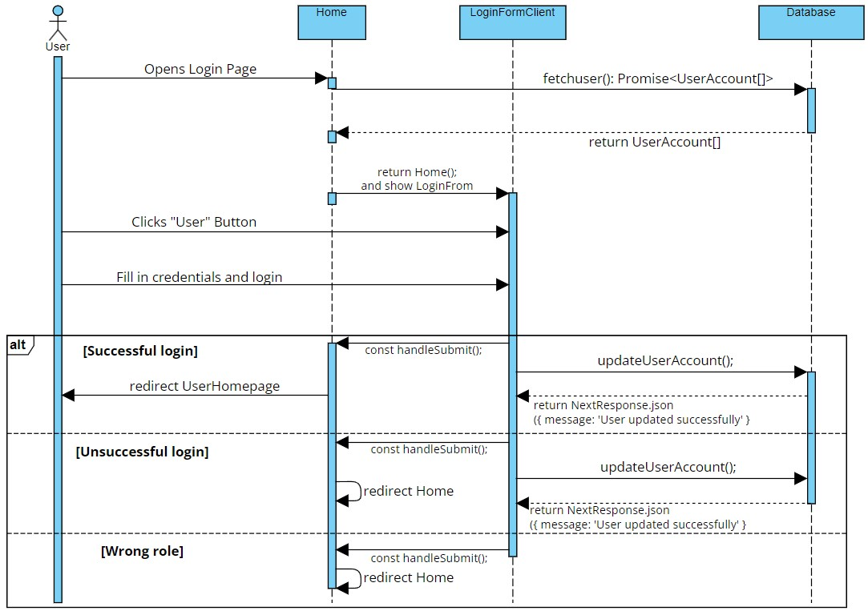

Case 2 (DONE)
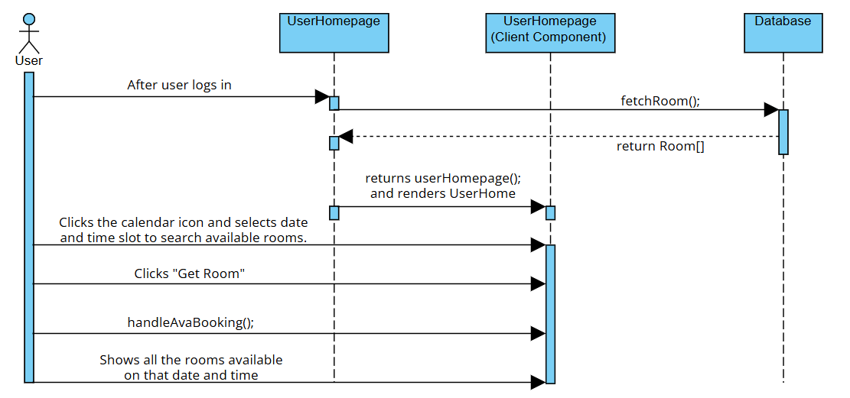

Case 3 (DONE)
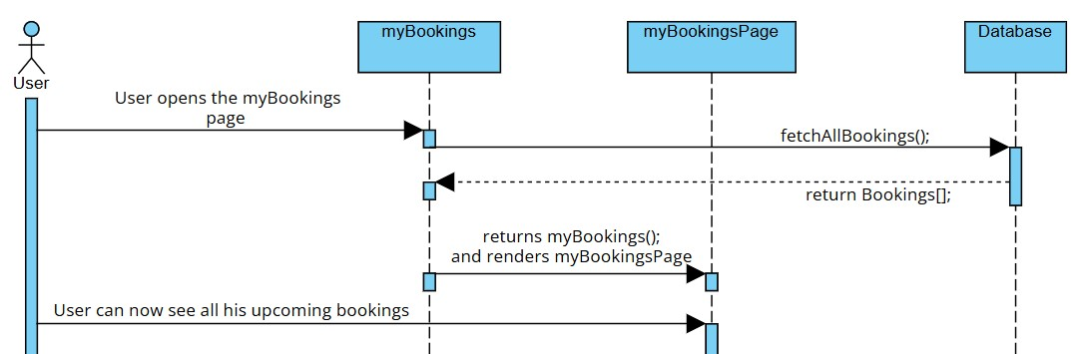

Case 4 (DONE)
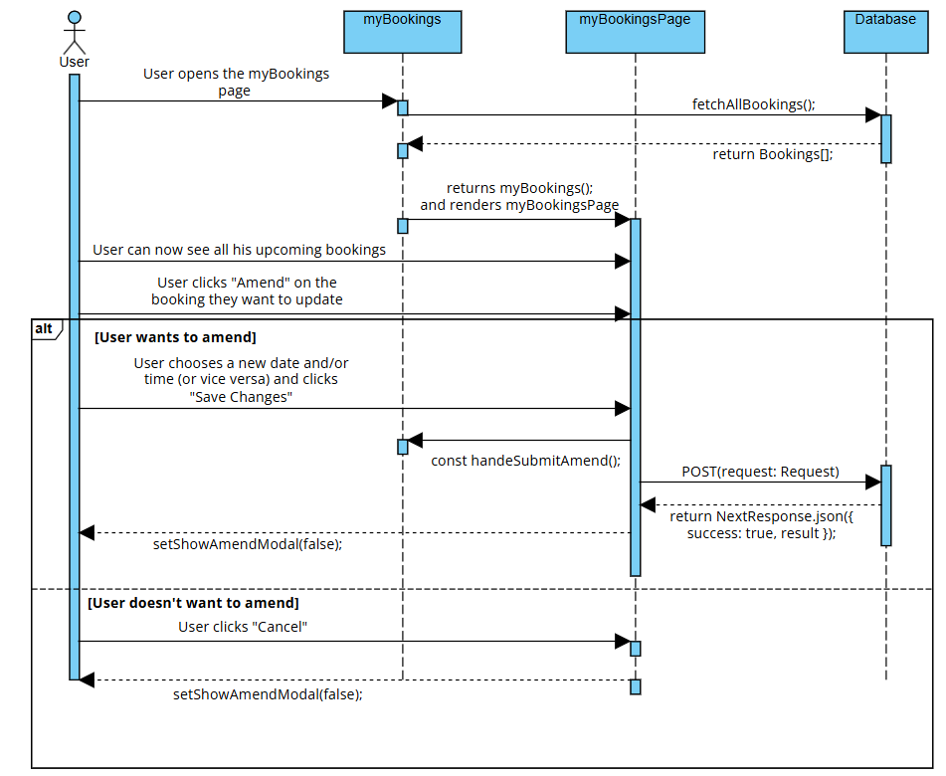

Case 5 (DONE)
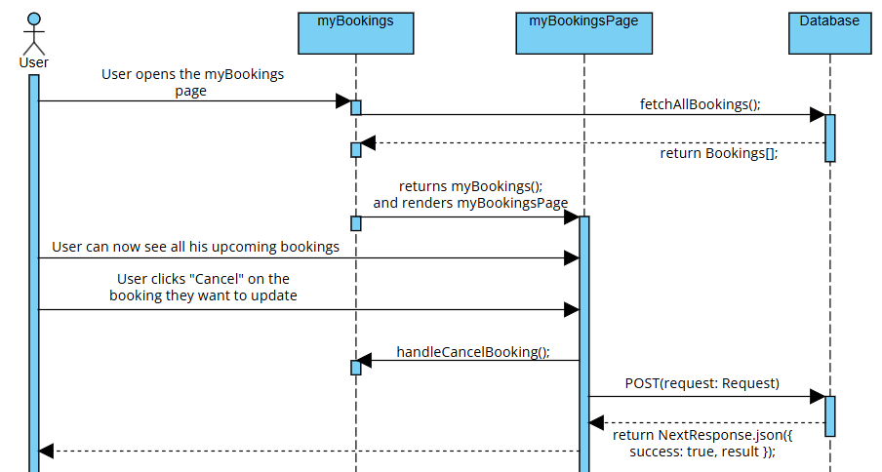

Case 6 (DONE)
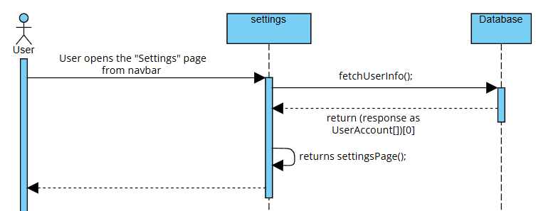
Case 7 (DONE)
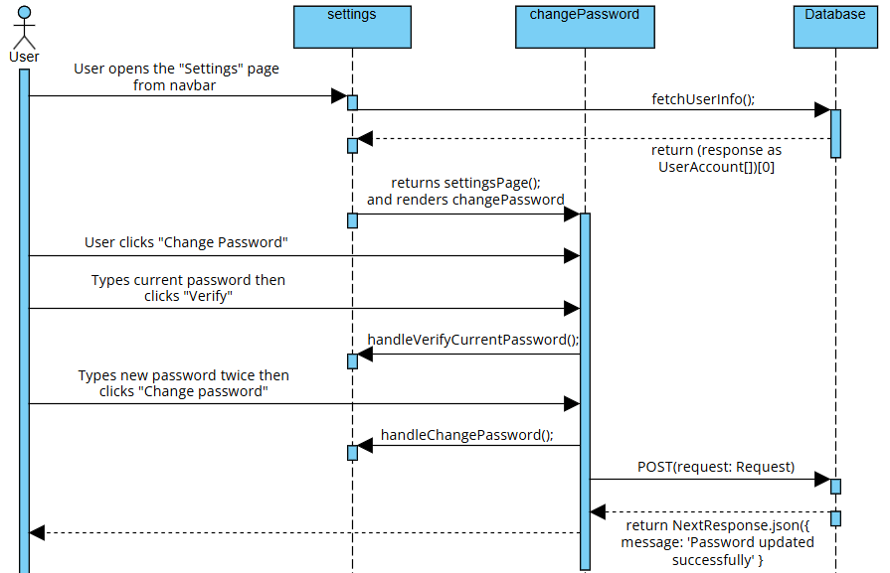
Case 8
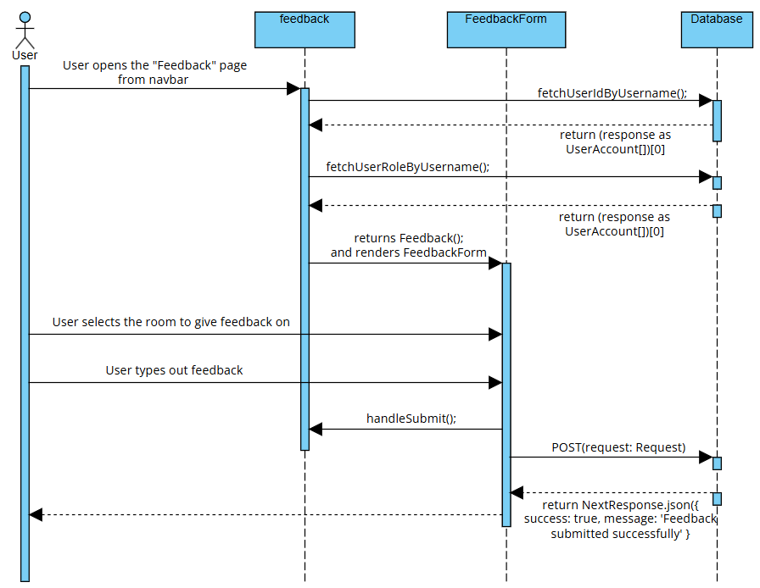
Case 9
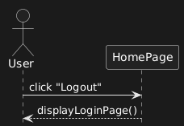
Case 10
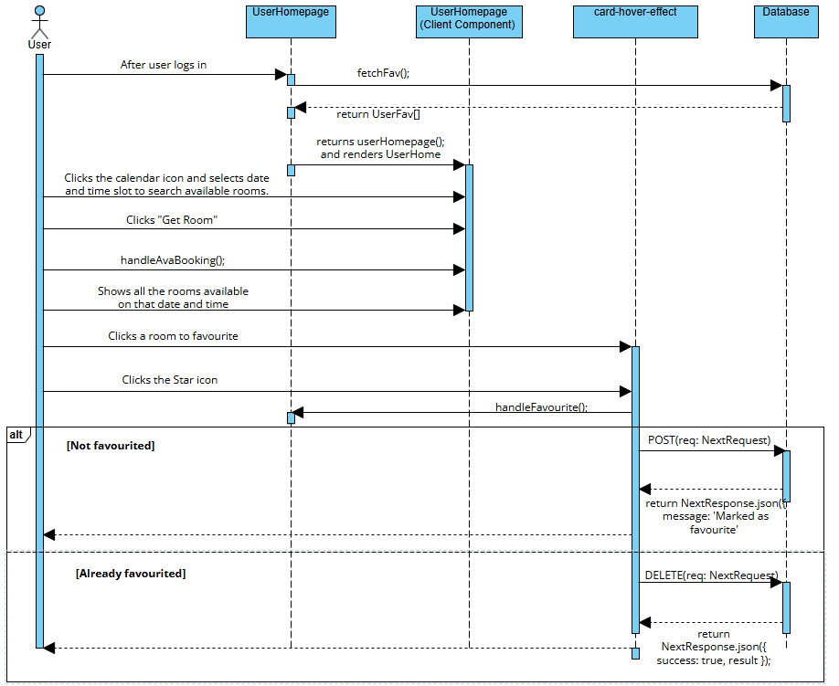

Case 11
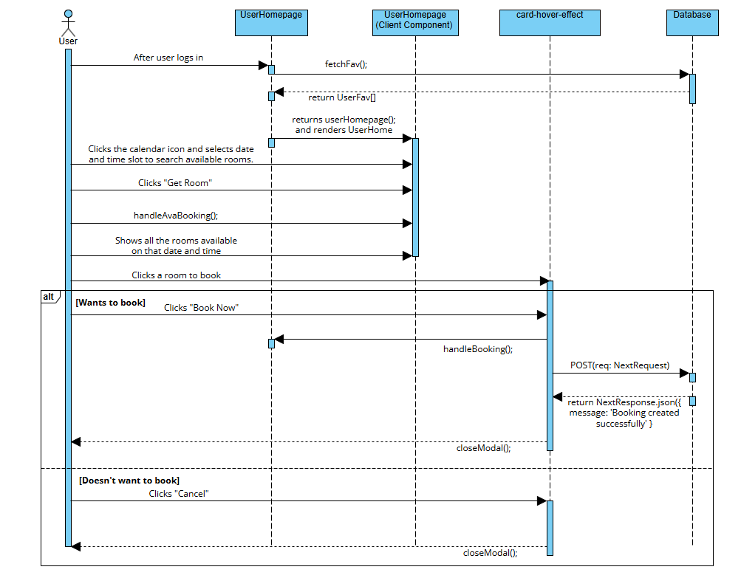

Admin
Case 1(DONE)
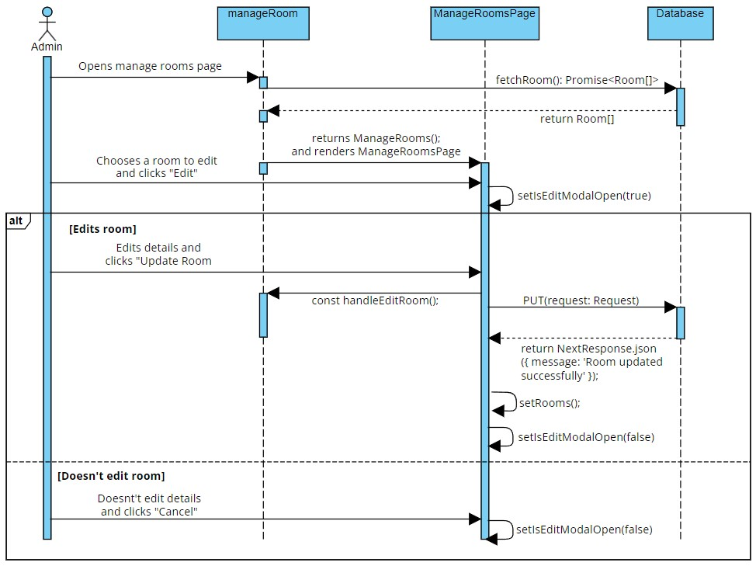

Case 2(DONE)
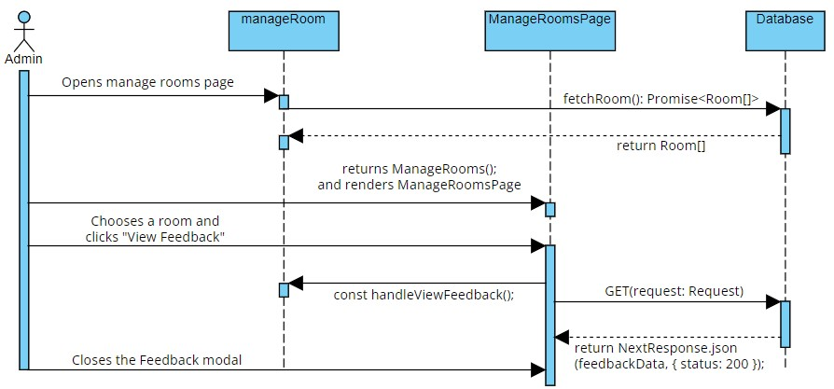

Case 3 (DONE)
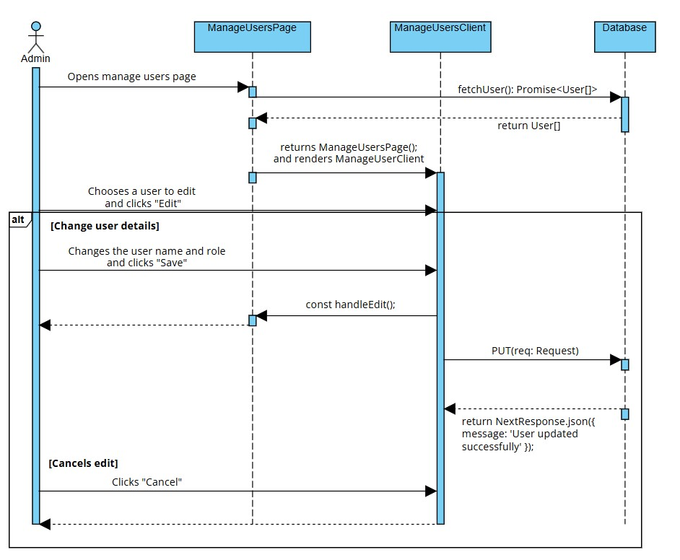

Case 4 (DONE)
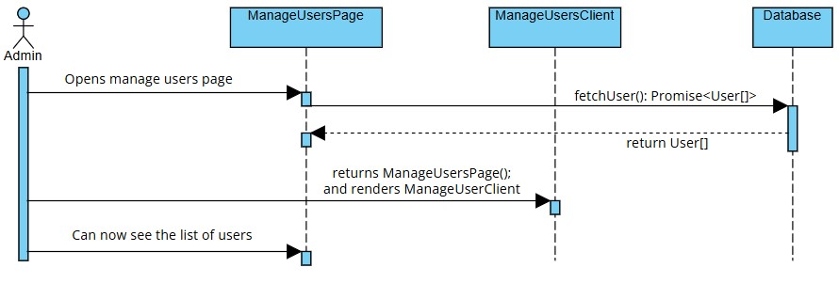

Case 5 (DONE)
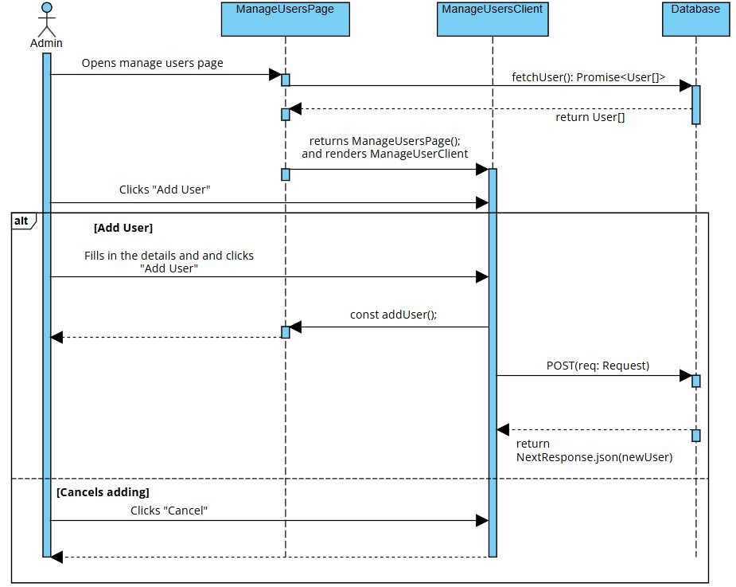

Case 6
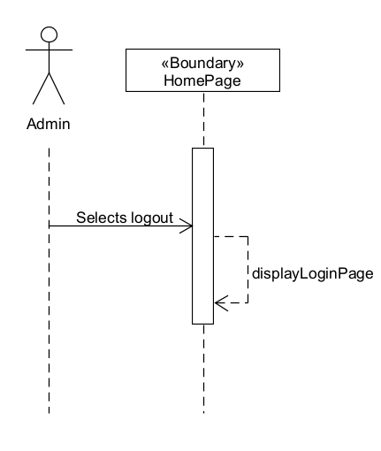

Case 7 (DONE)
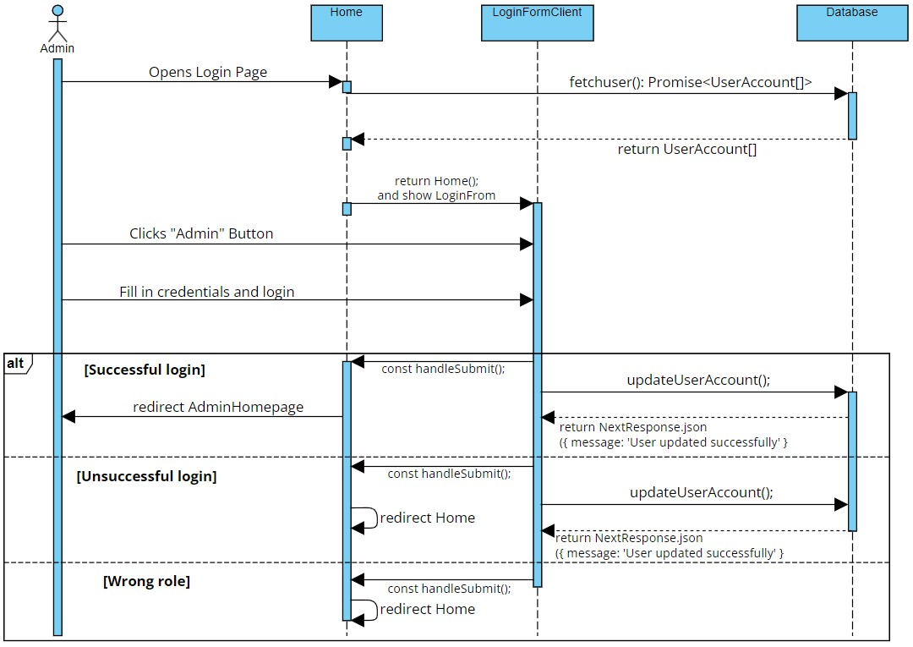

Case 8 (DONE)
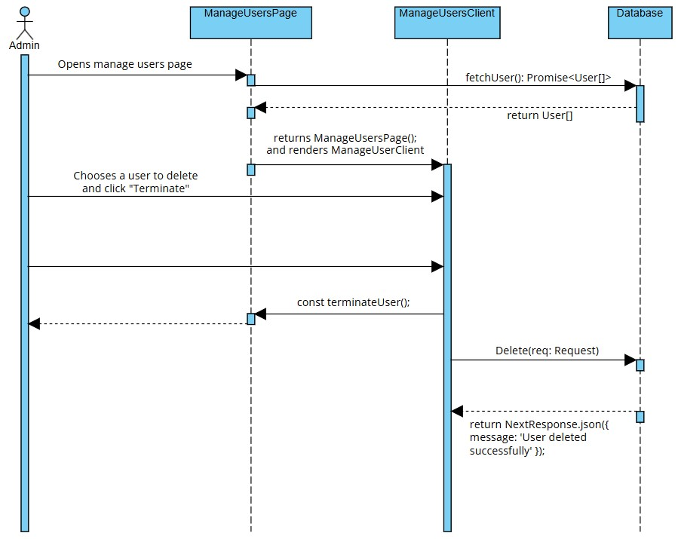

Director
Case 1 (Login)
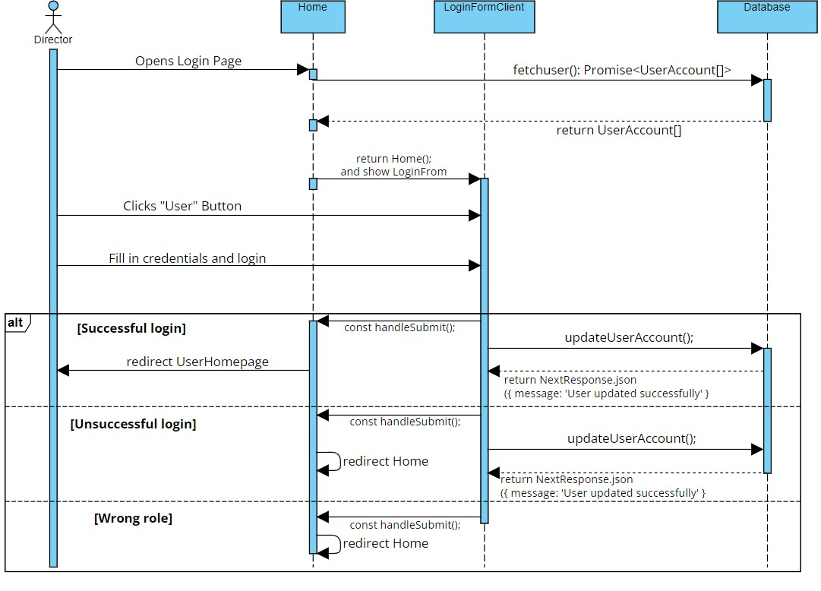

Use case: ID2 (Search)
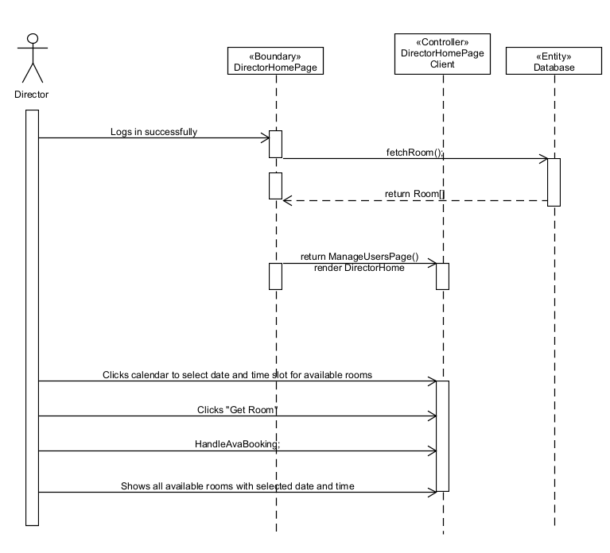

Use case: ID3 (Override)
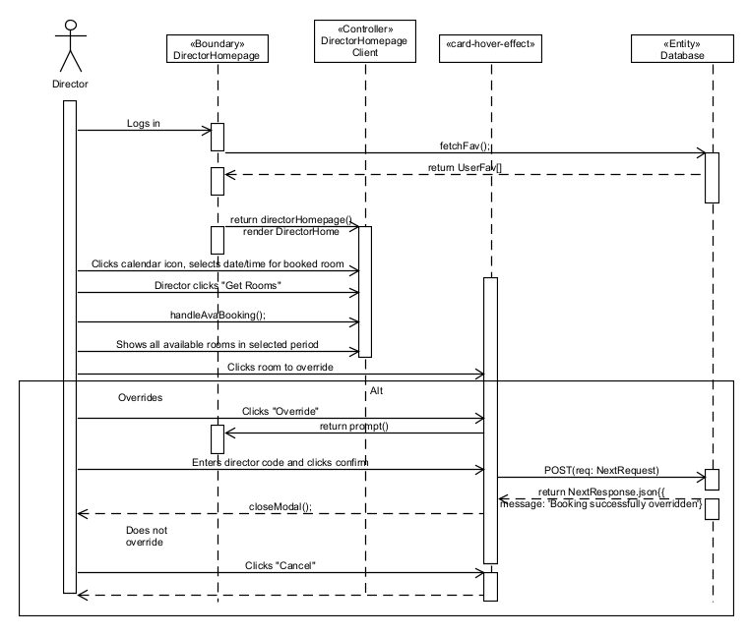

Use case: ID4 (View)
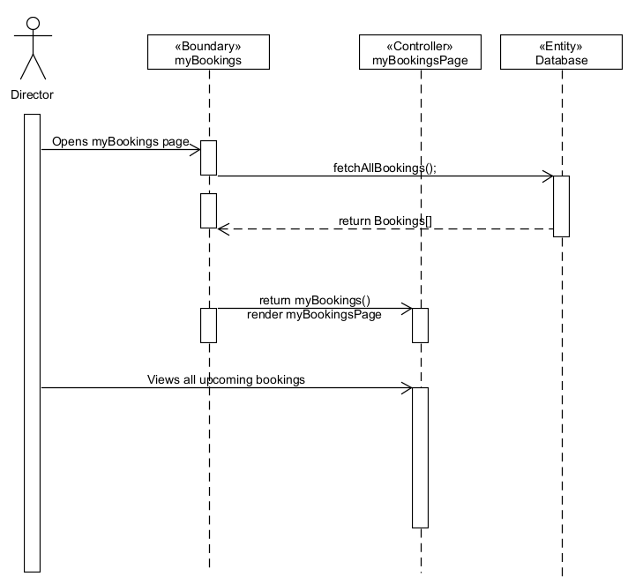

Use case: ID5 (Delete)
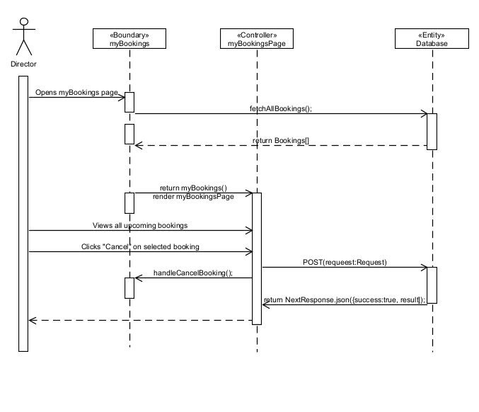

Use case: ID6 (Update)
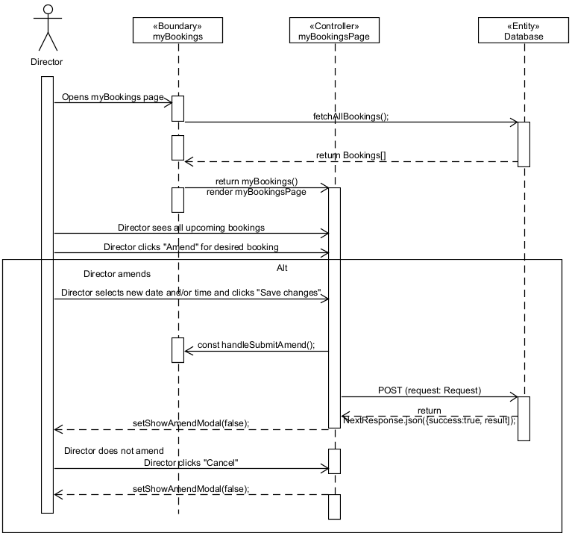

Use case: ID7 (Logout)
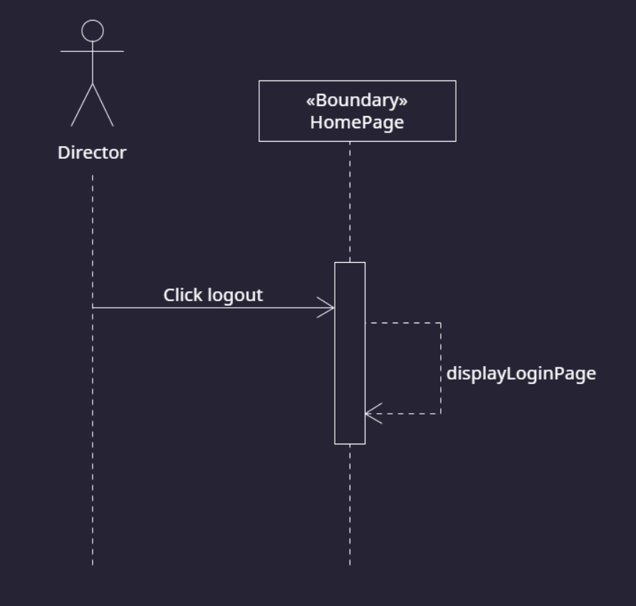

Use case: ID8 (Exclusive)
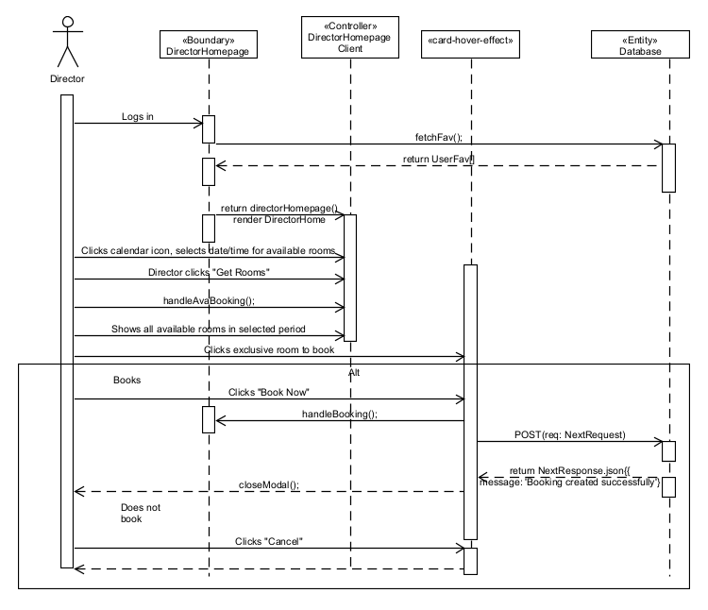

Use case: ID9 (Review)
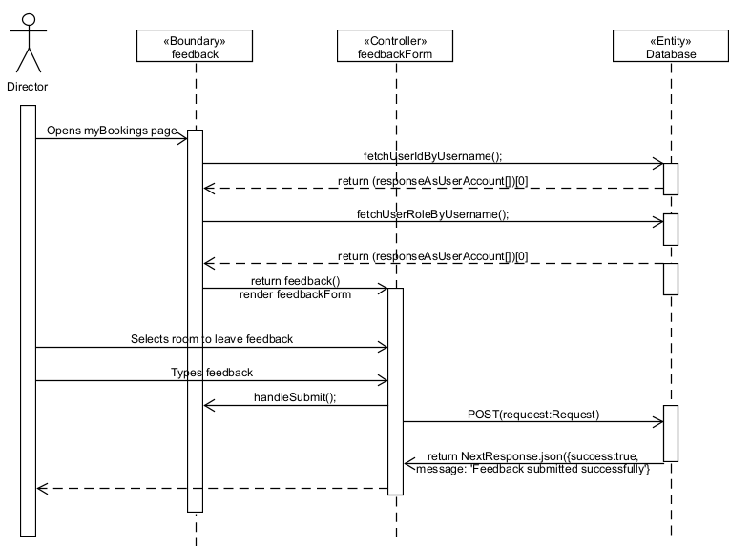

Use case: ID10 (Favourite)
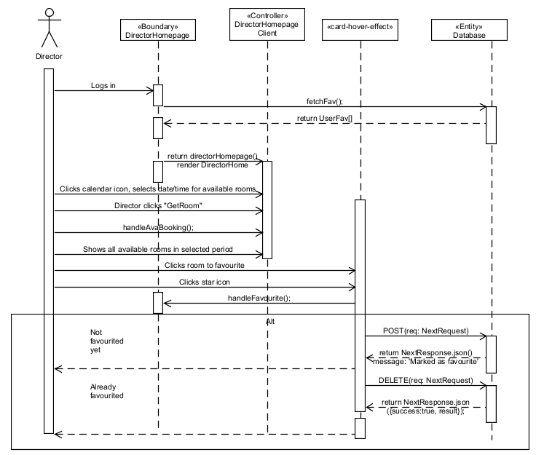

Use case: ID11 (Book)
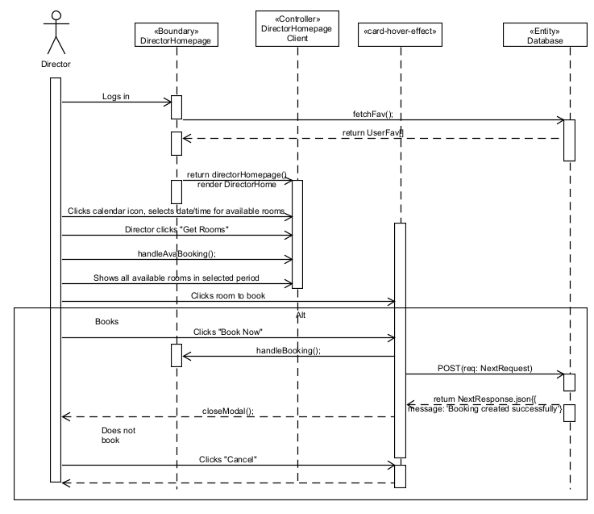

Use case: ID12 (View Acc)
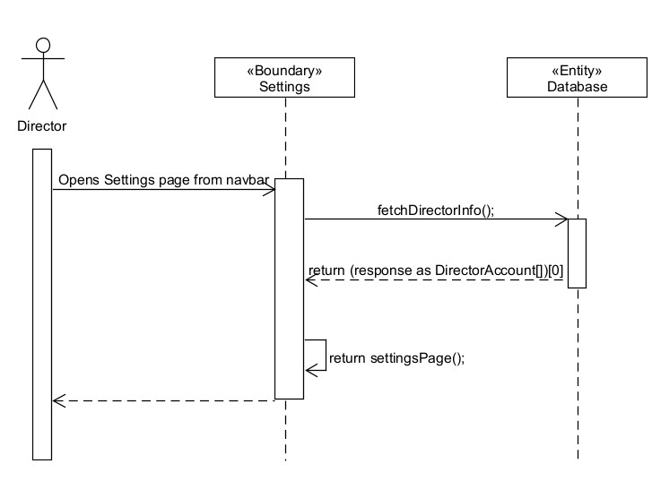

Use case: ID13 (Change Password)
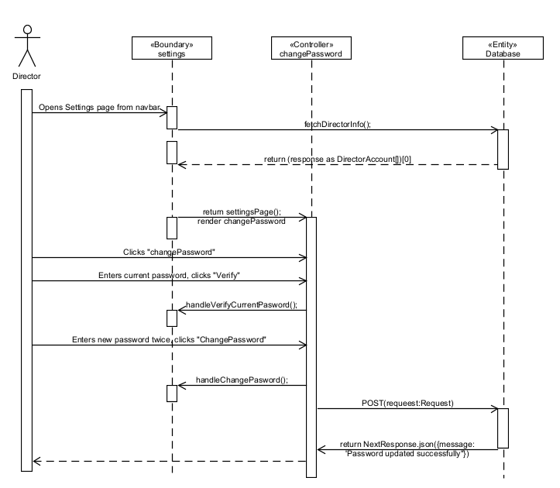

Mobile
Use Case ID1 (User, DONE)
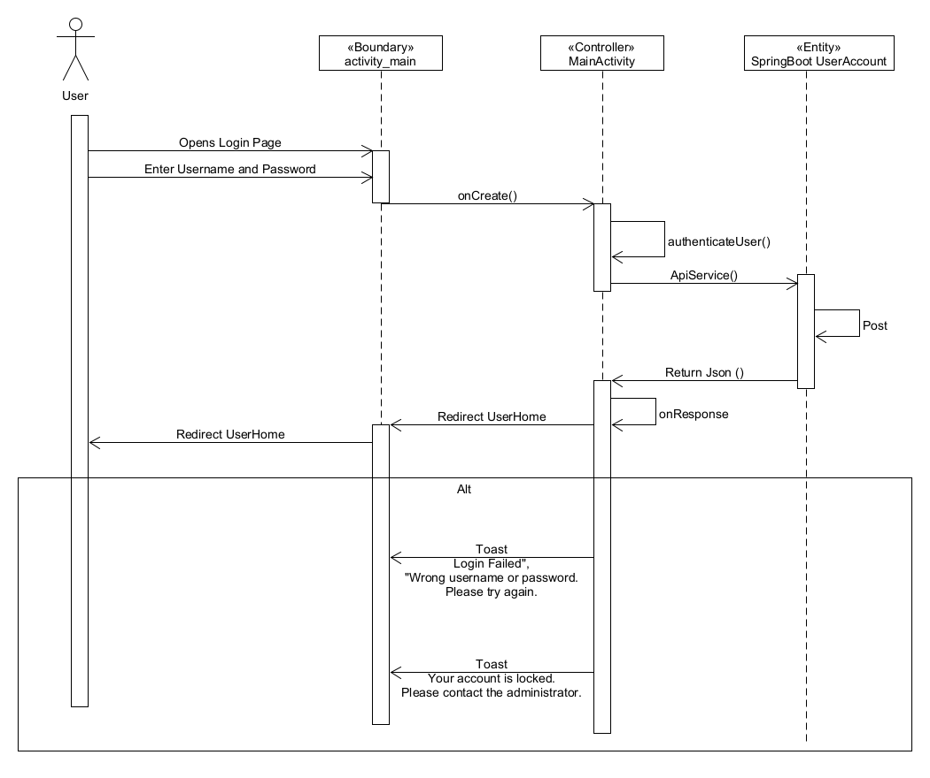

Use Case ID2 (User, DONE)
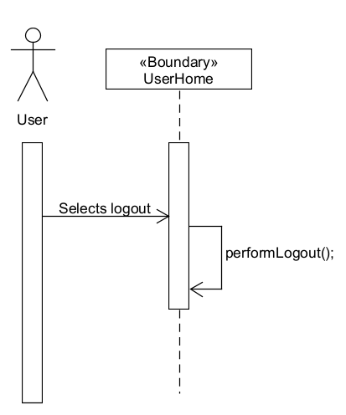

Use Case ID3 (User, DONE)
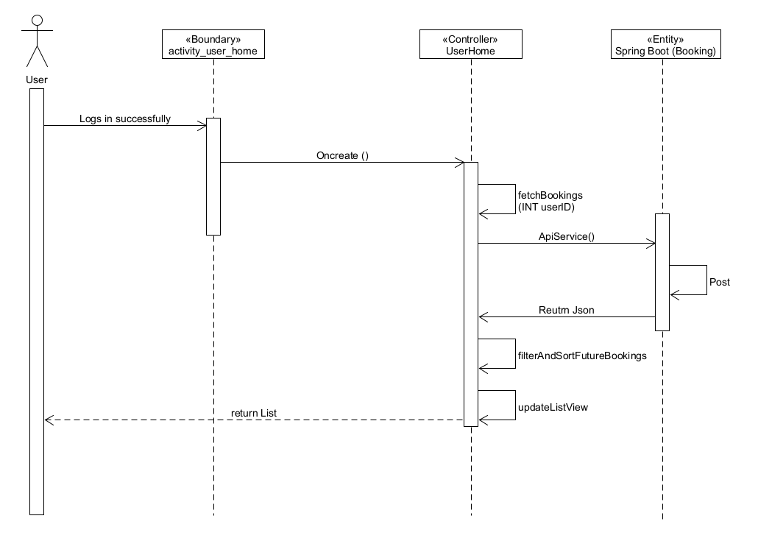

Use Case ID4 (User, DONE)
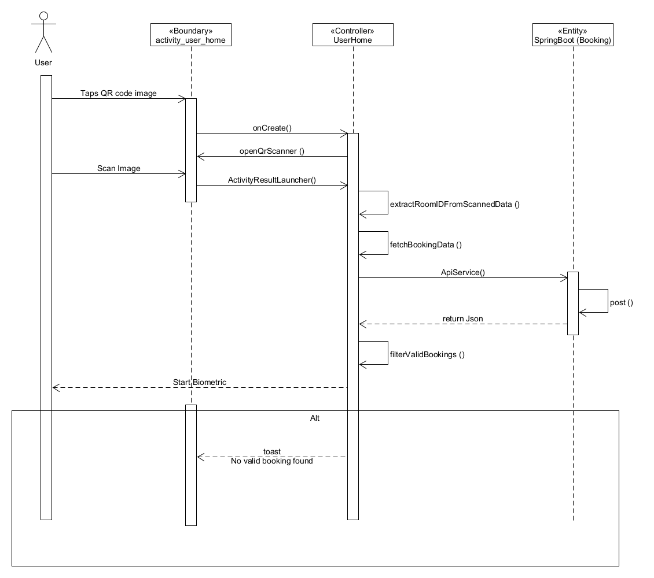
Use Case ID5 (User, DONE)
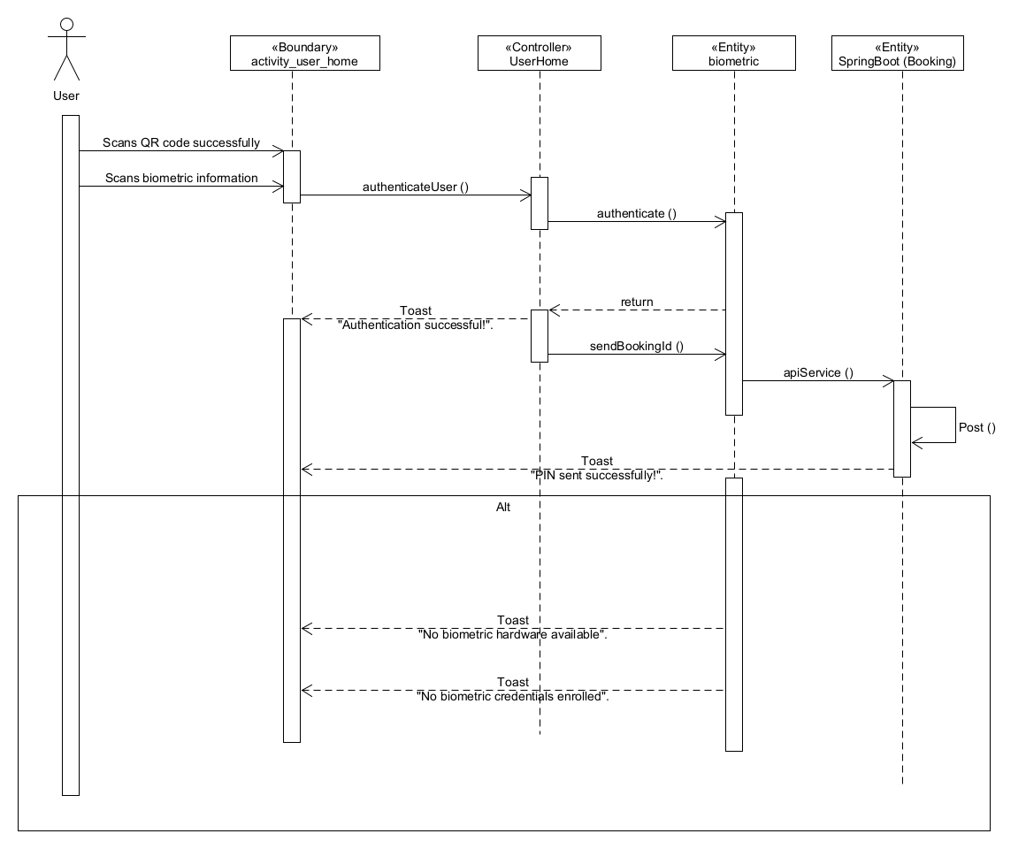

Use Case ID1 (Director, DONE)
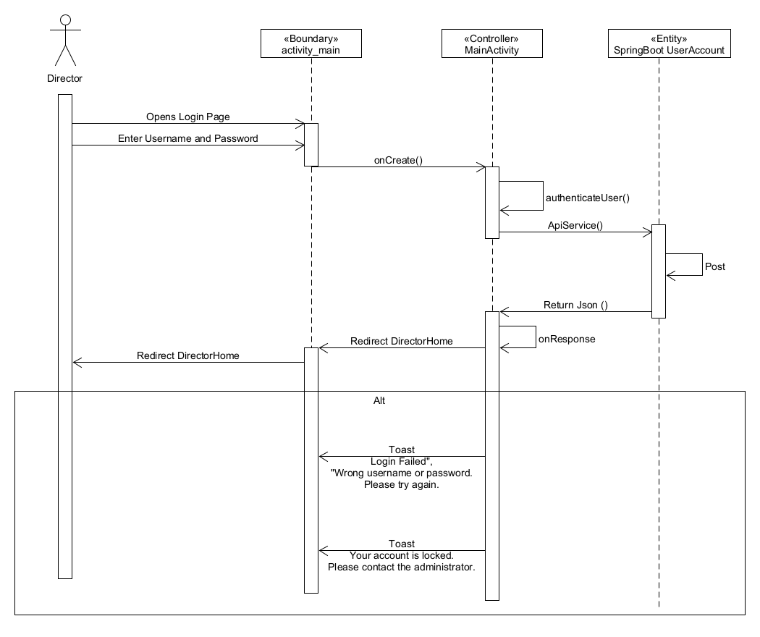
Use Case ID2 (Director, DONE)
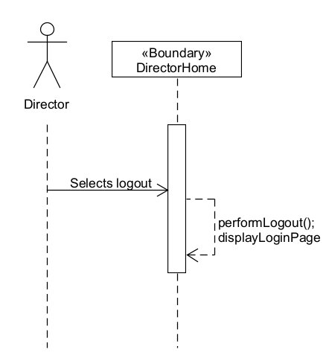

Use Case ID3 (Director, DONE)
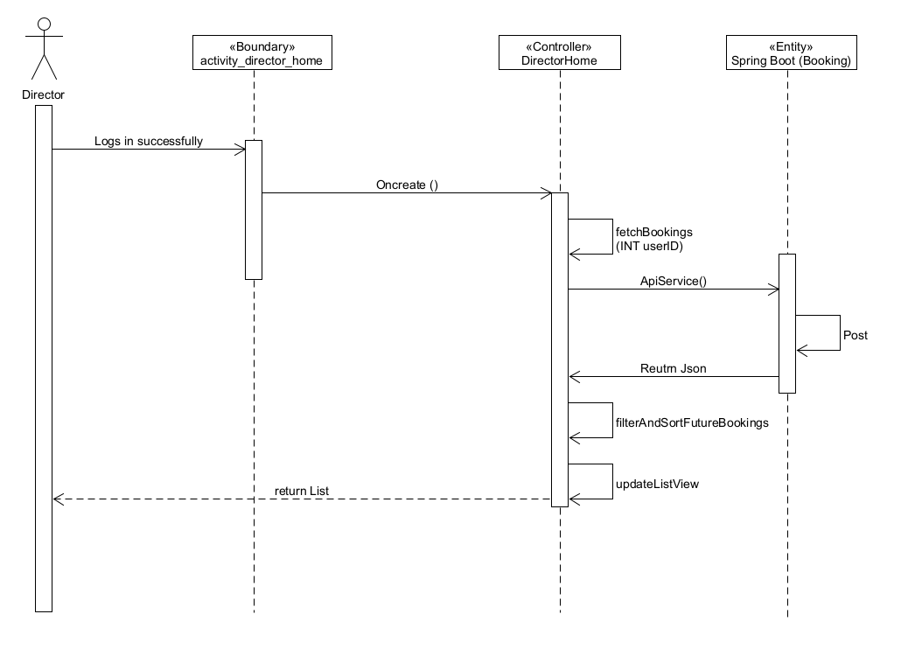
Use Case ID4 (Director, DONE)
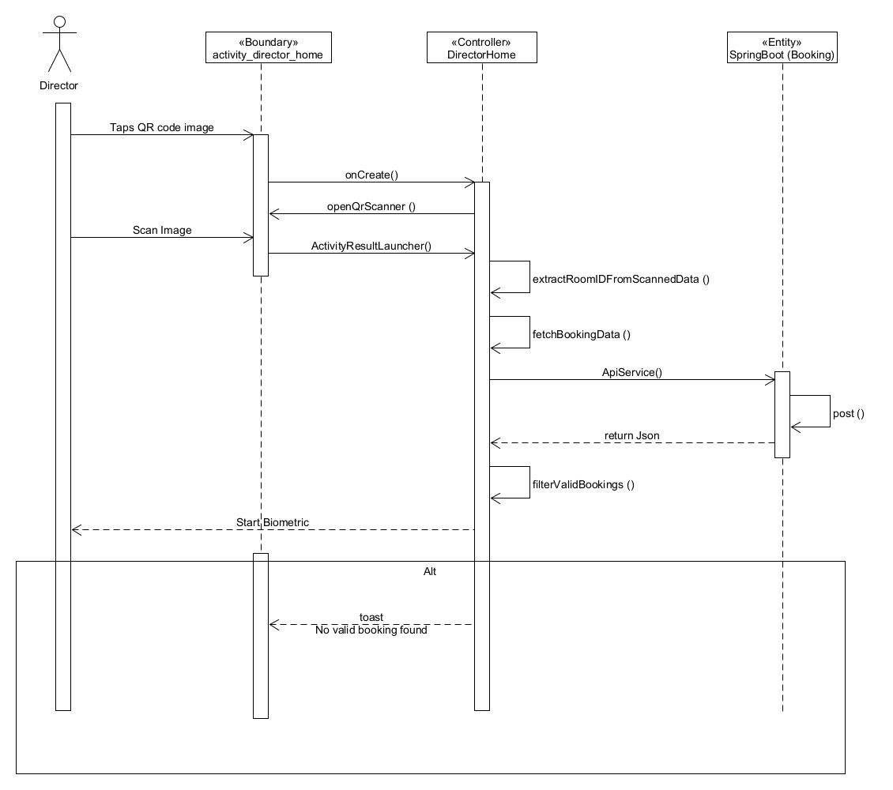
Use Case ID5 (Director, DONE)
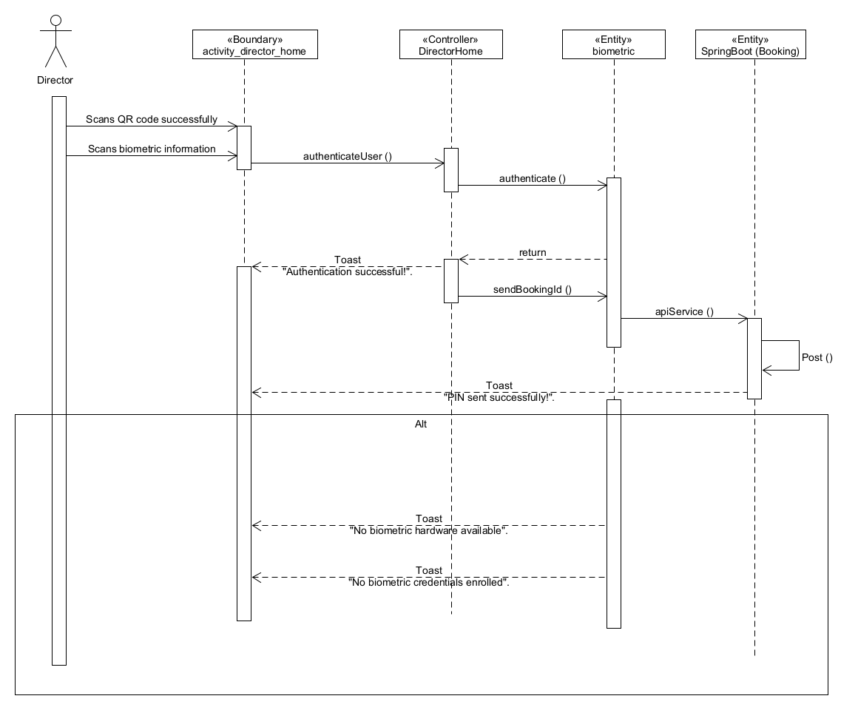

Function Hierarchy Diagram
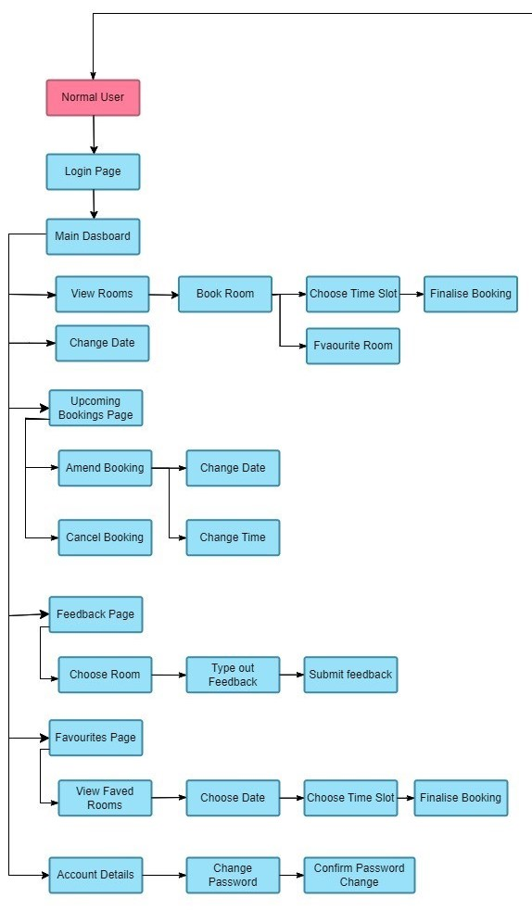
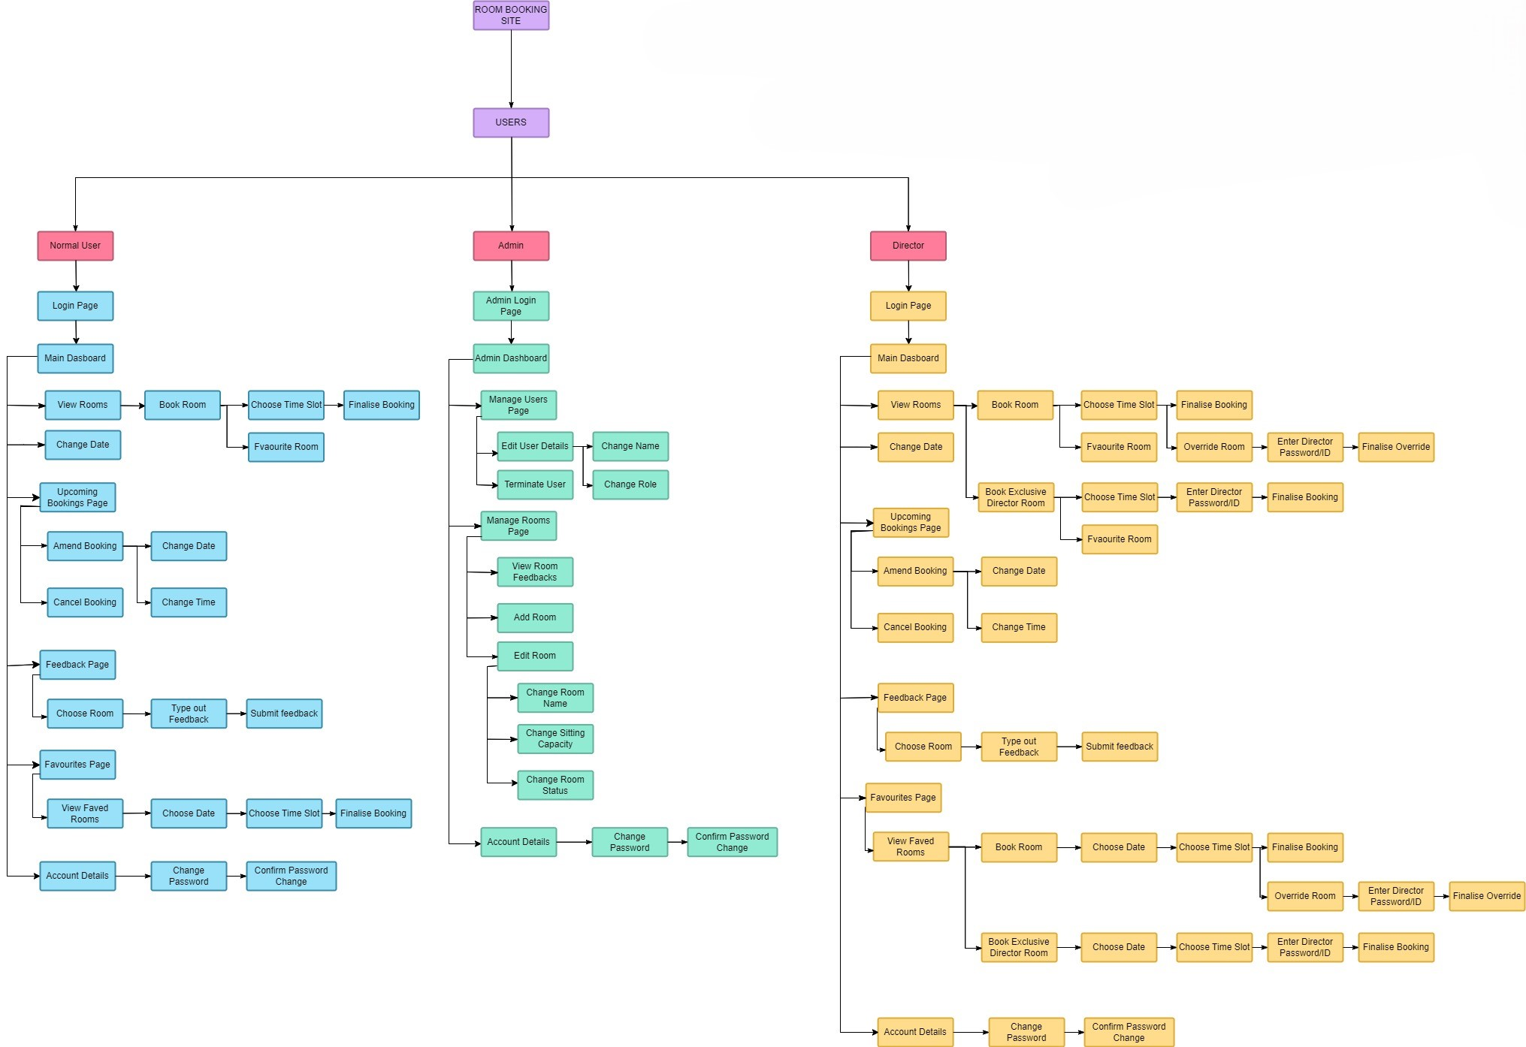
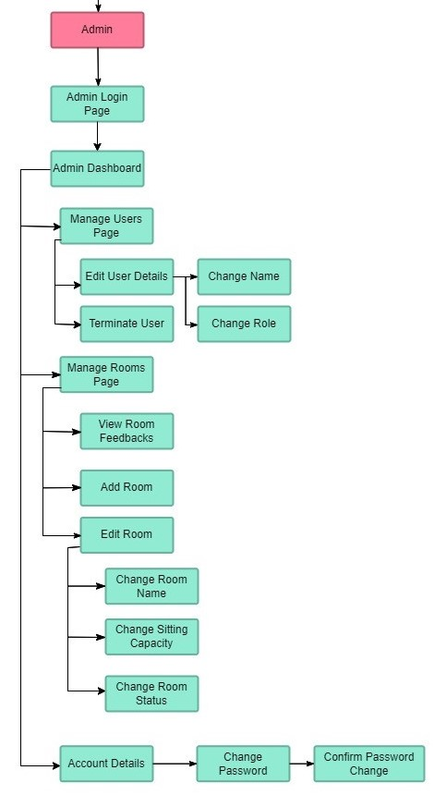

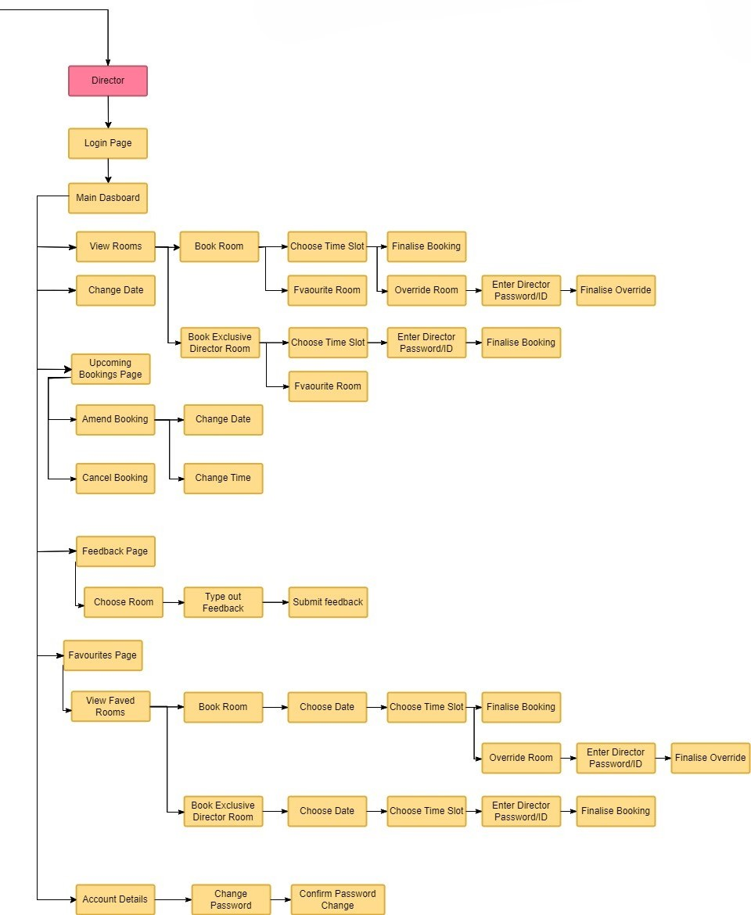

8. WireFrame

Webpage

Login page for user and director
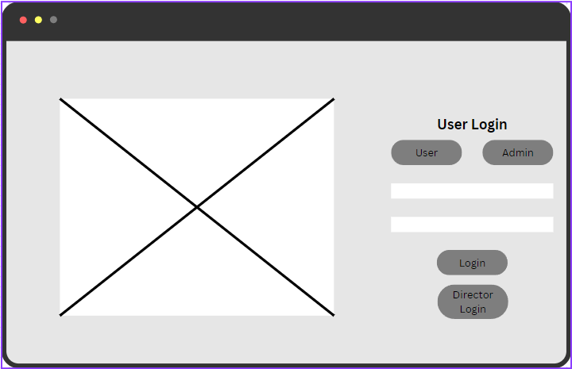

Viewing of rooms for User and Director
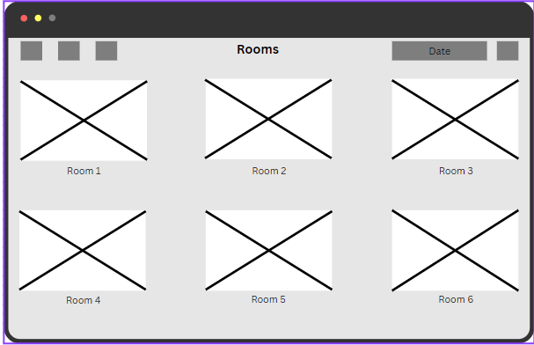

Confirmation of booking
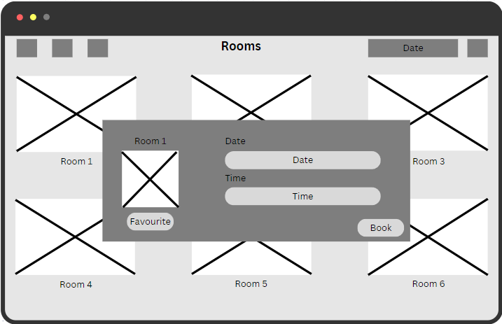

Feedback form for room

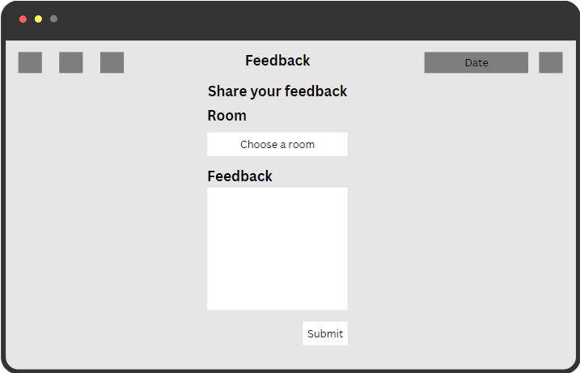

List of current bookings
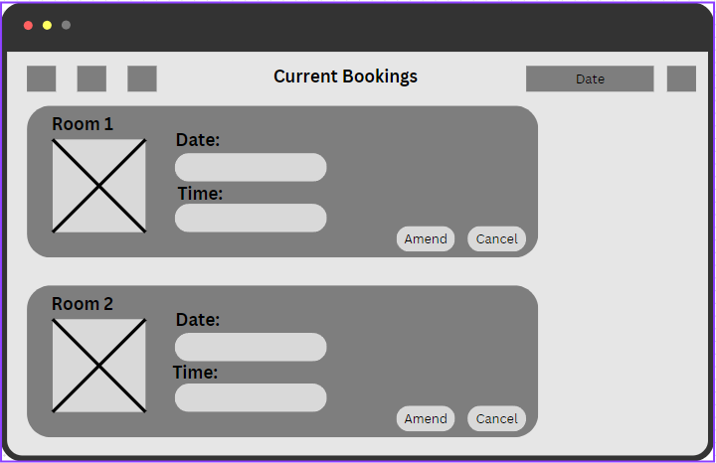

Login page for Admin
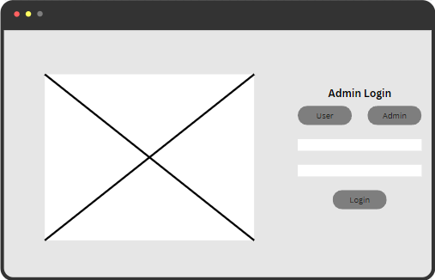

Homepage for Admin
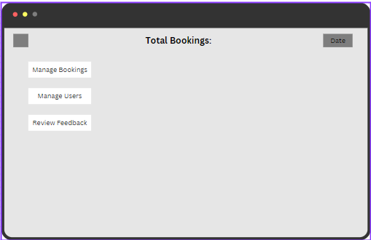

Page to manage rooms
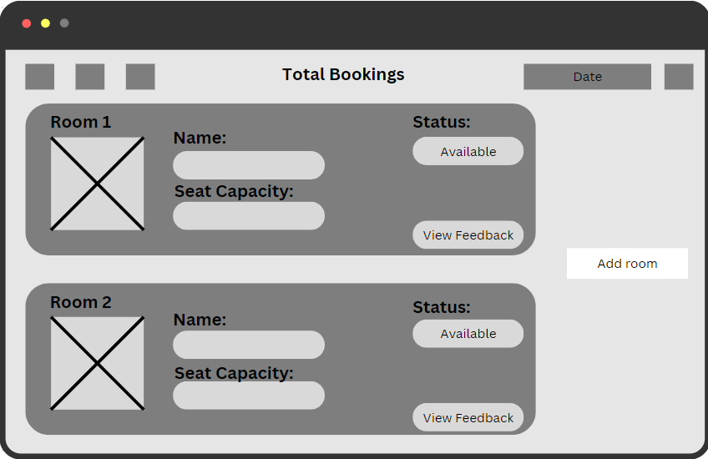

Page to manage users
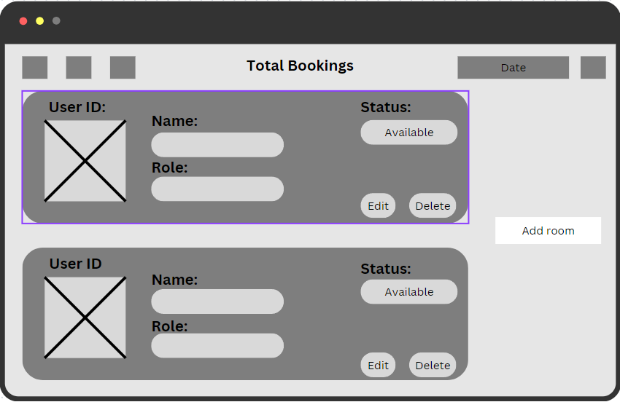

Page to view feedback on particular room
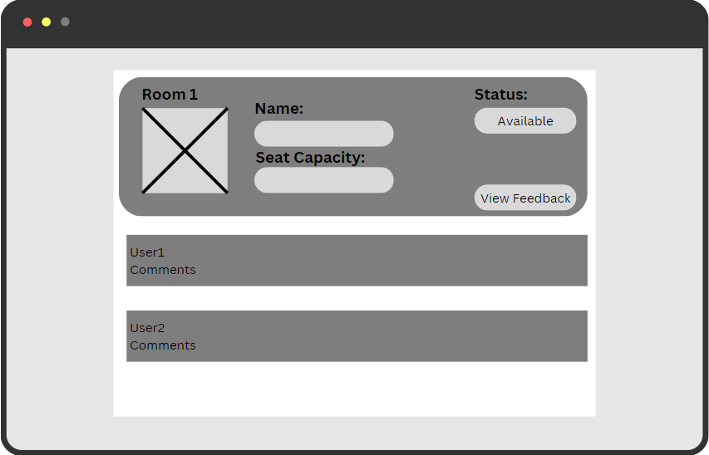

Account details page
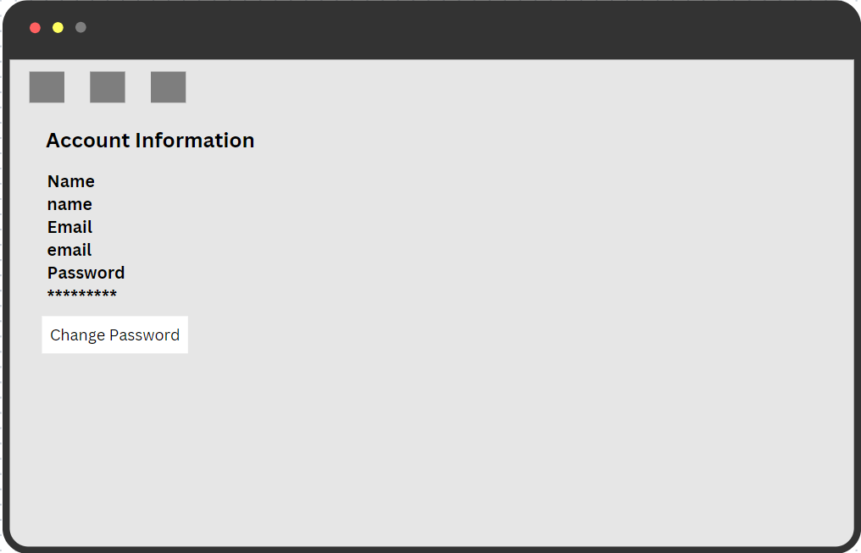

Mobile

User and Director login page
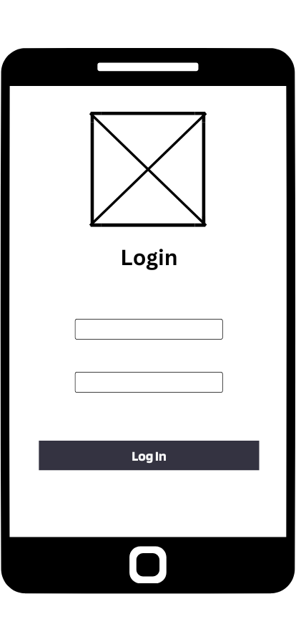

User and Director View Booking
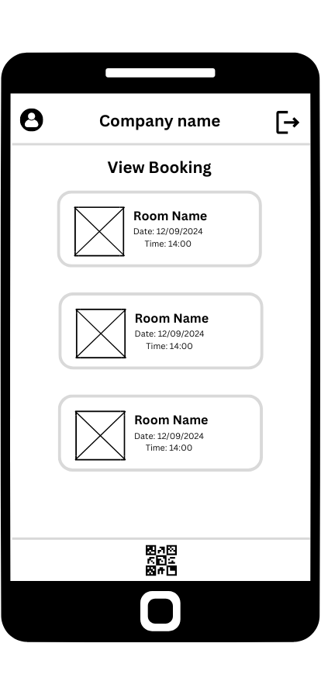

User and Director scan QR code

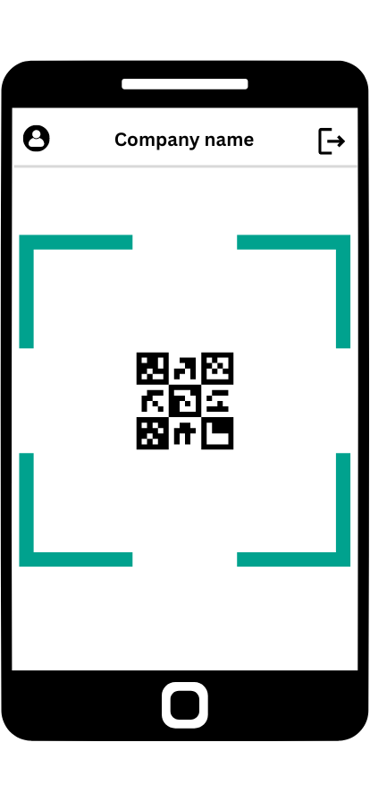

User and Director Biometric scan
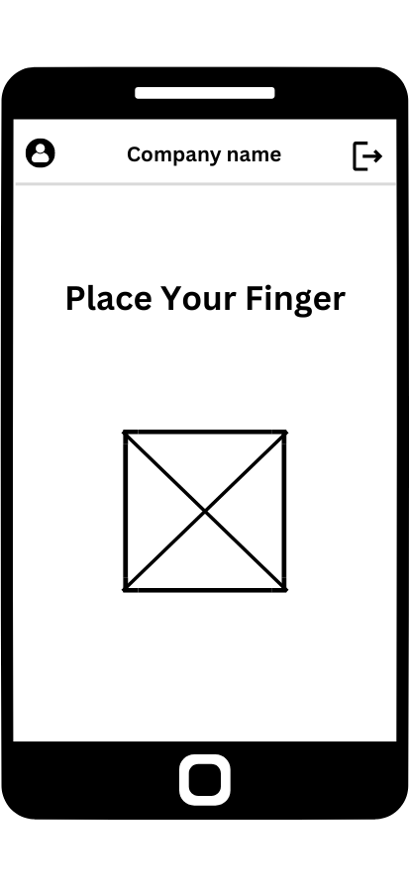

Successful Biometric and receive PIN

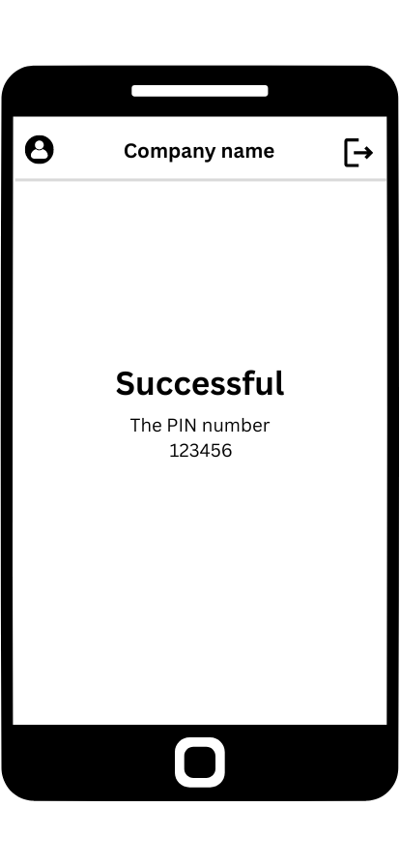

9. Prototype
Webpage
https://www.figma.com/proto/7Hpbtnp7qaqSvENAN2DdX4/QR-ROOM-BOOKING?node-id=0-1&t=RSWDEOKLZAtmVFkI-1

Mobile
https://www.figma.com/proto/Sc77Qx90St3Scg30QnVHg6/QR-Phone-App?node-id=0-1&t=noPPLgE5hp3huyCM-1

10. ERD
